**Week 4**

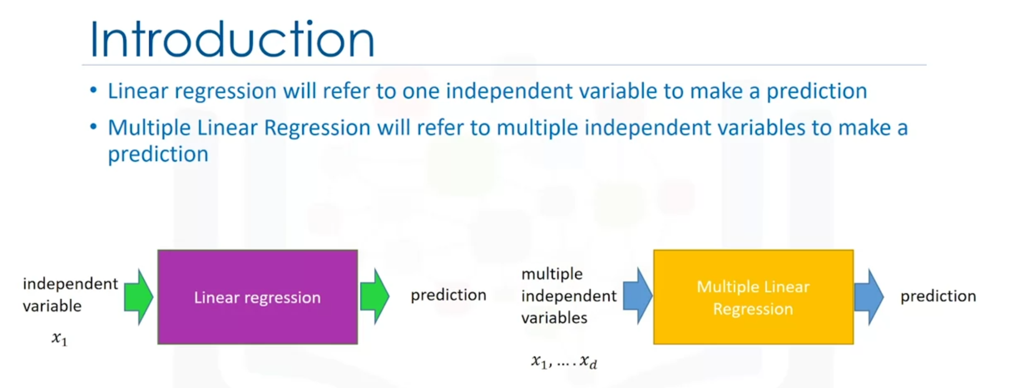

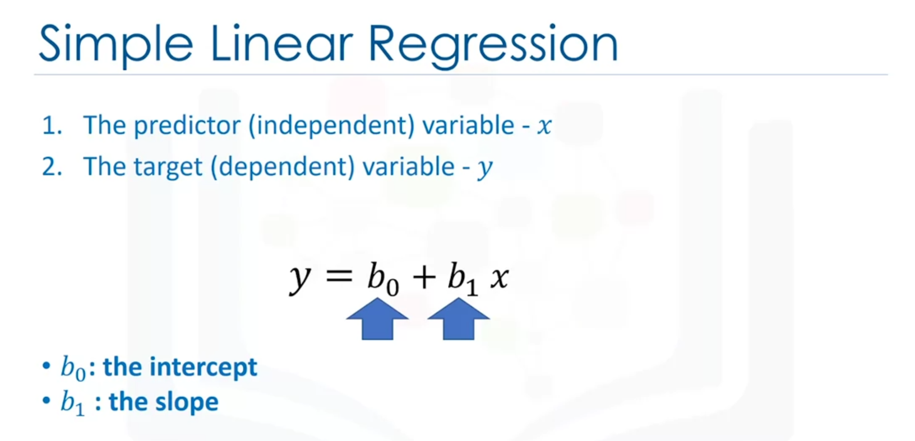

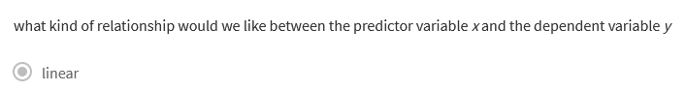

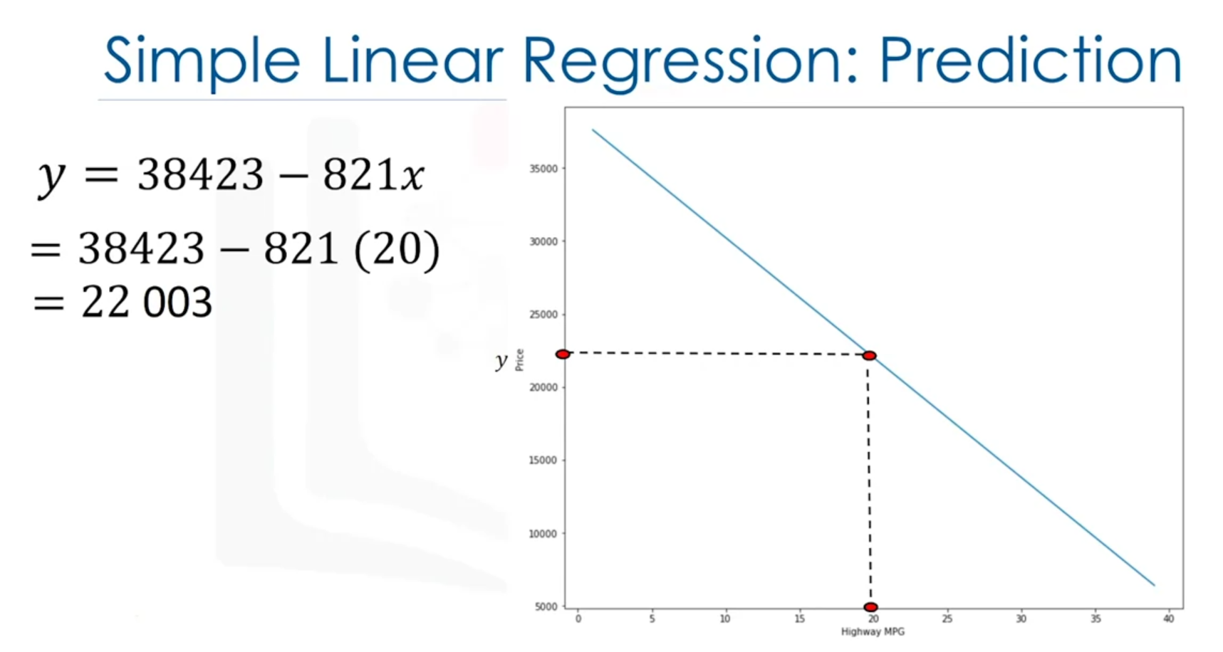

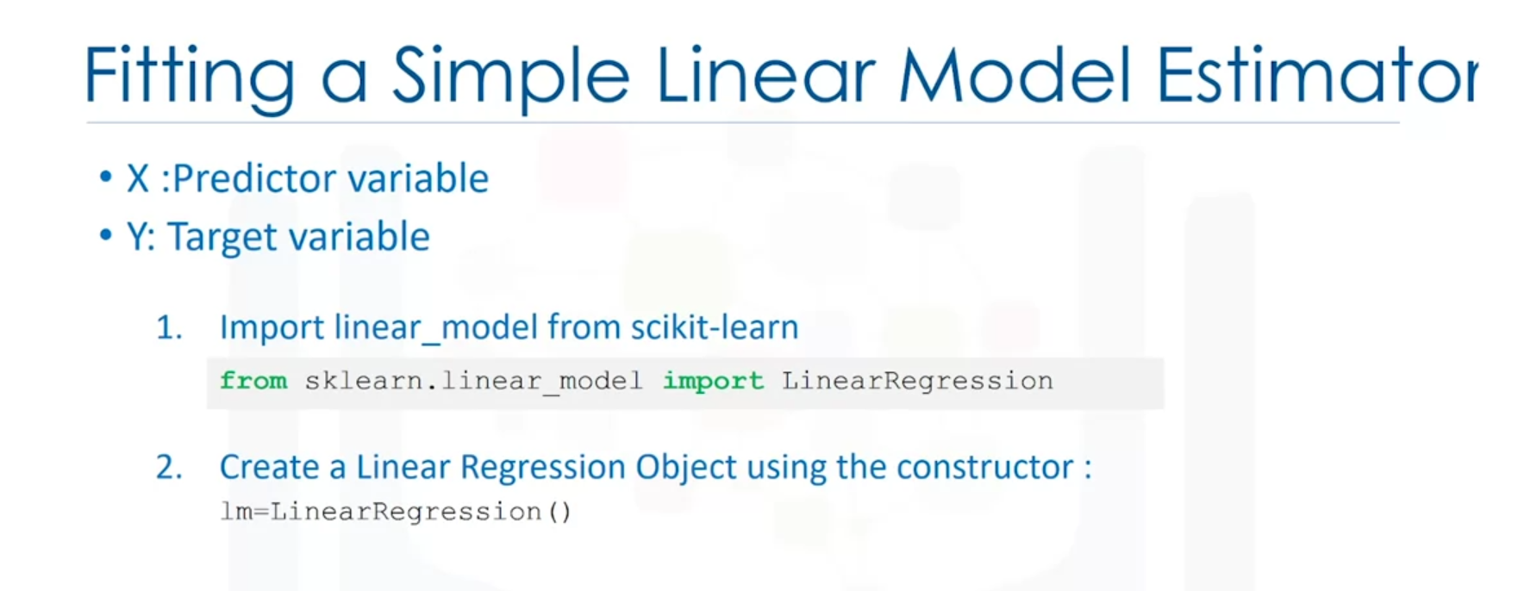

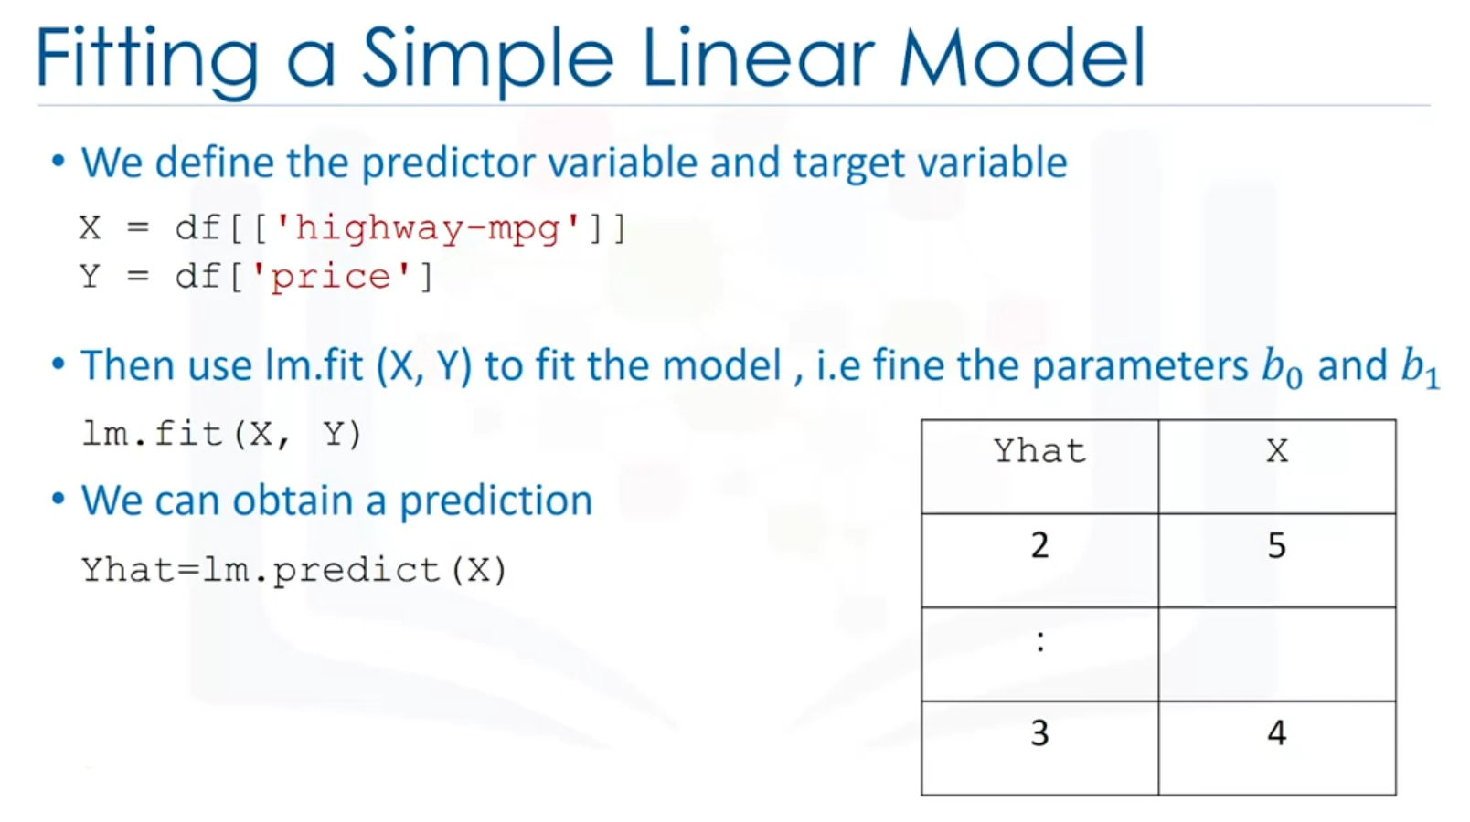

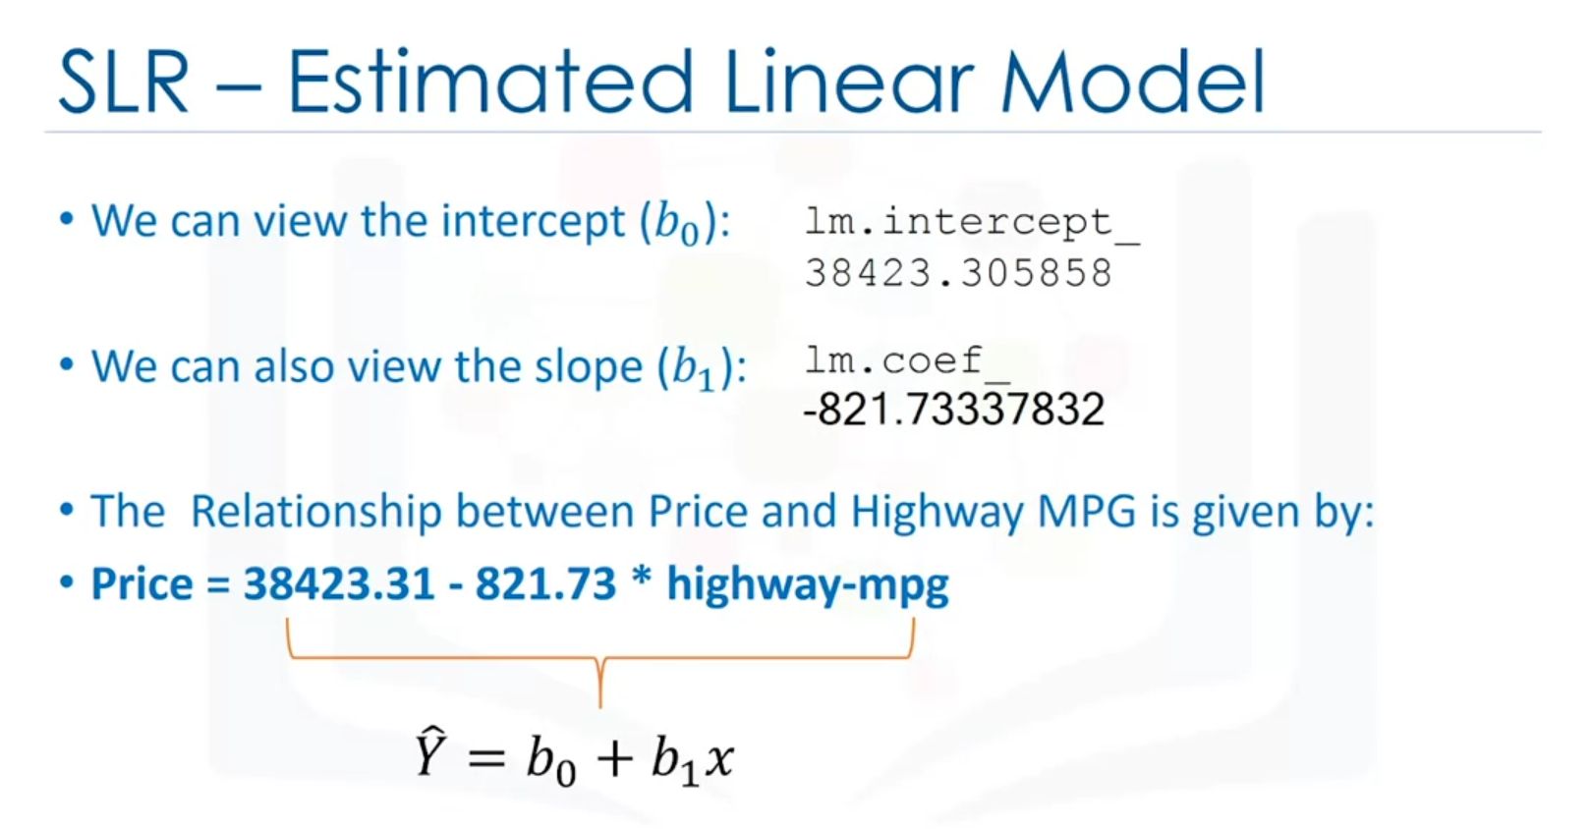

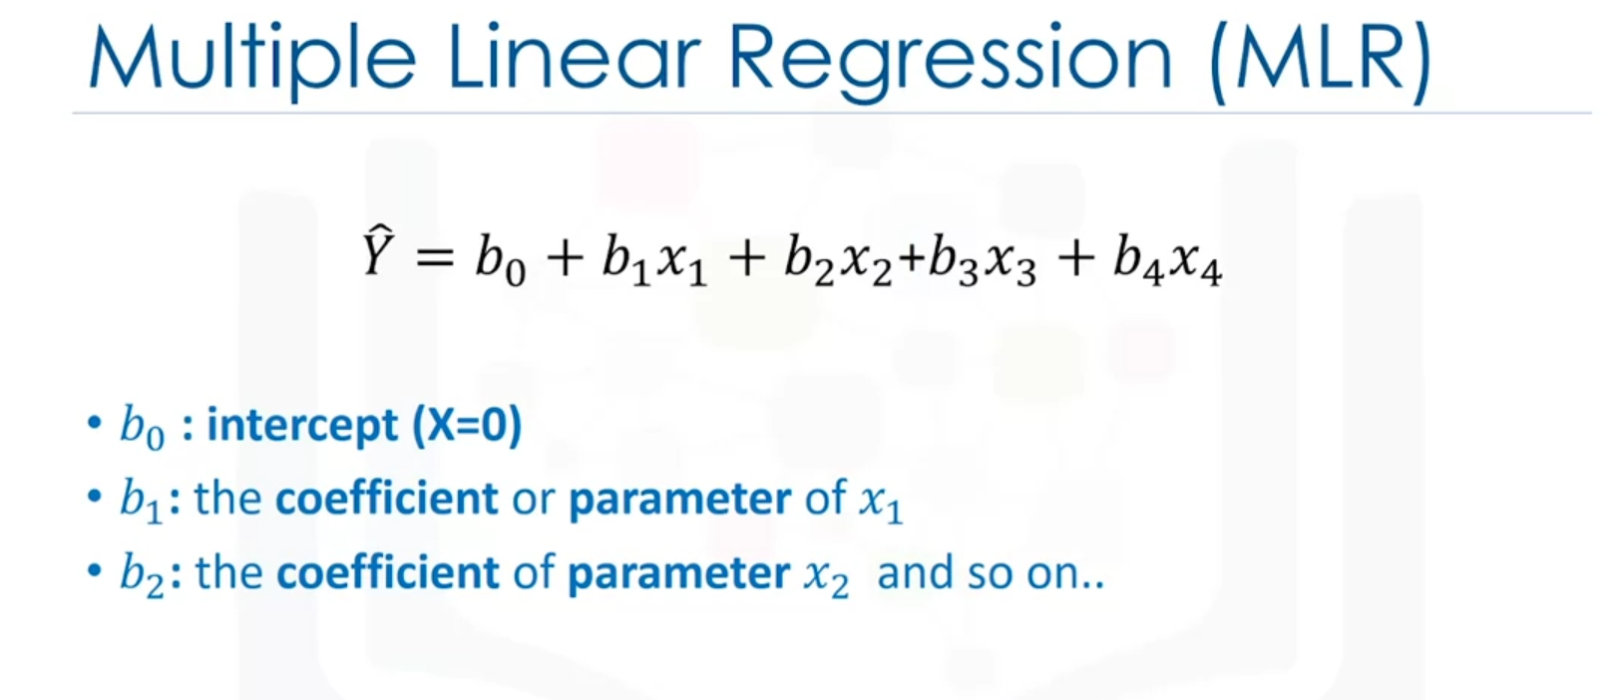

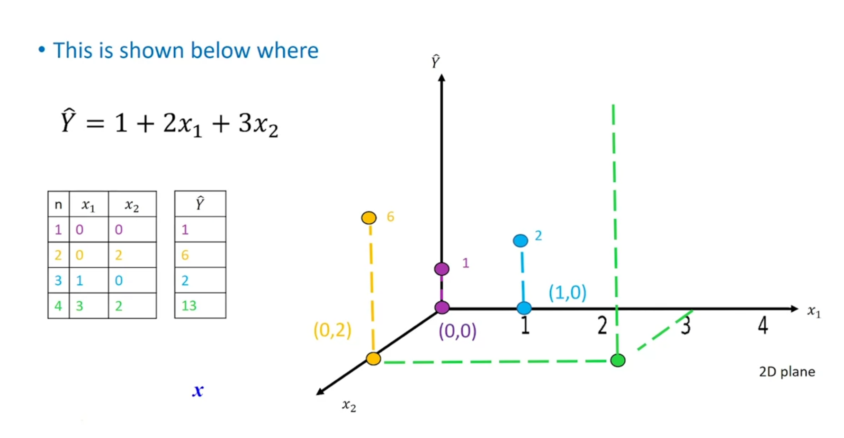

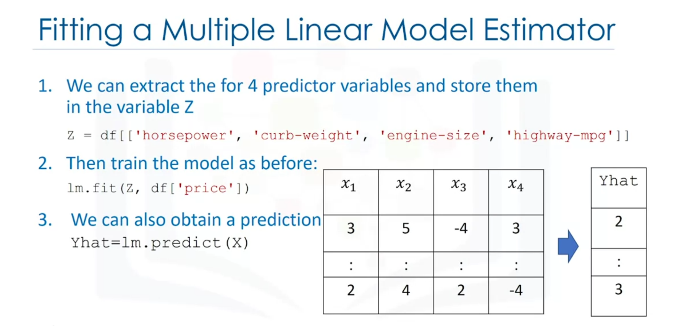

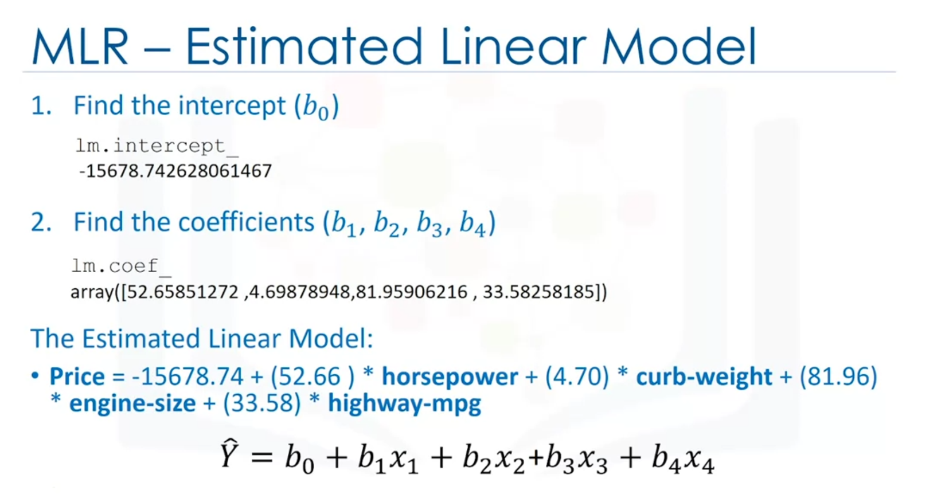

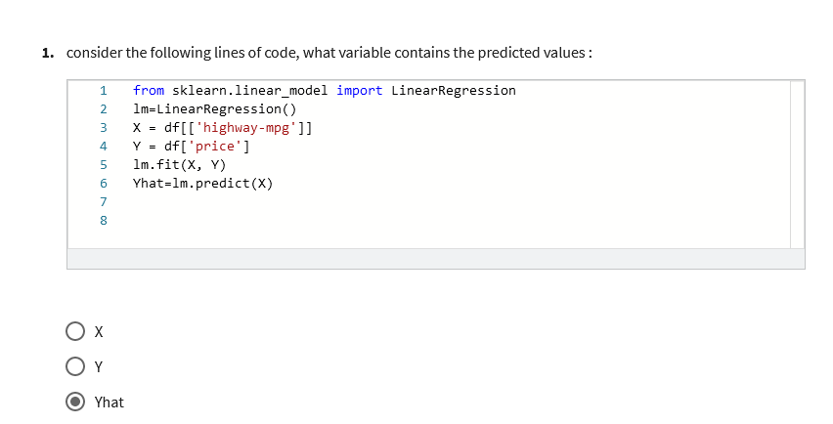

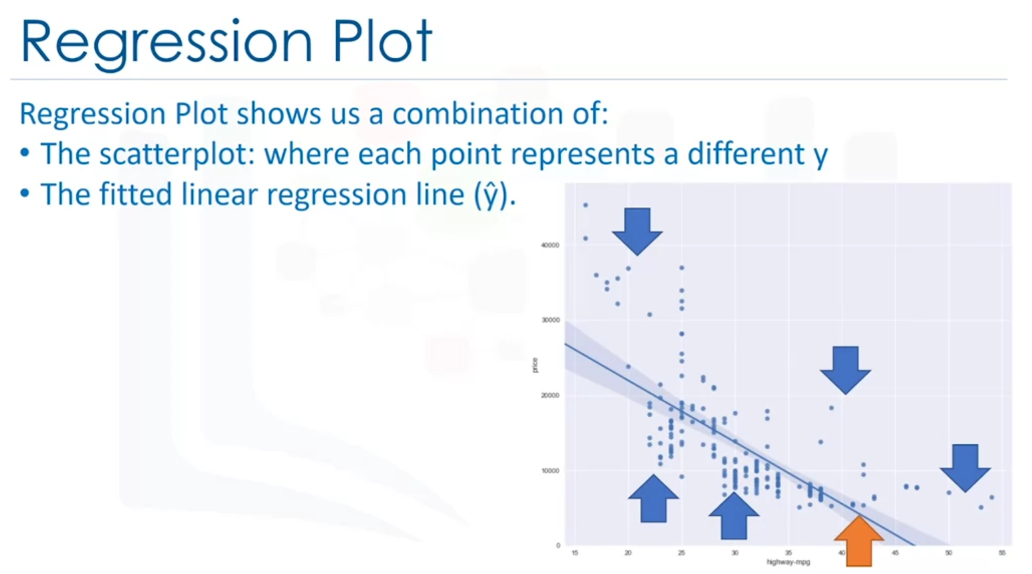

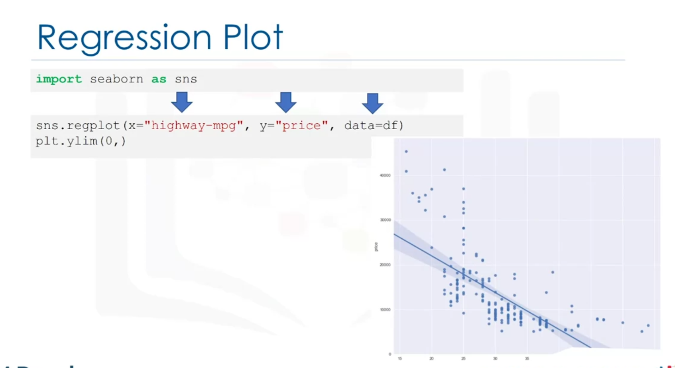

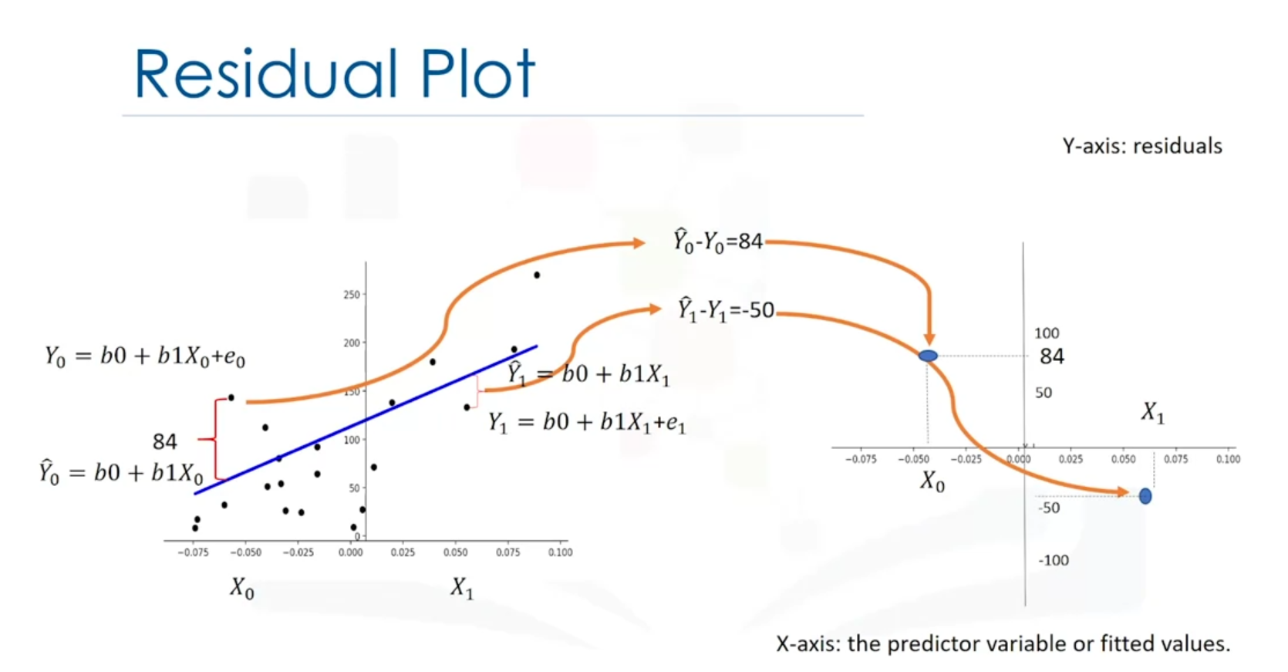

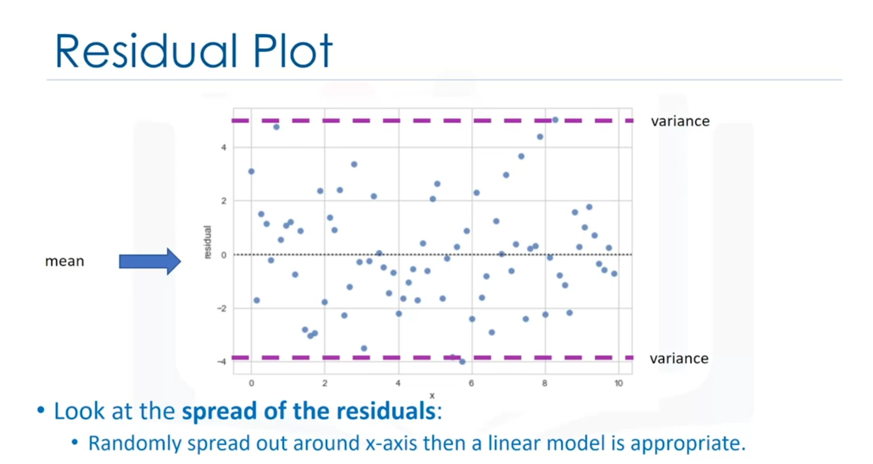

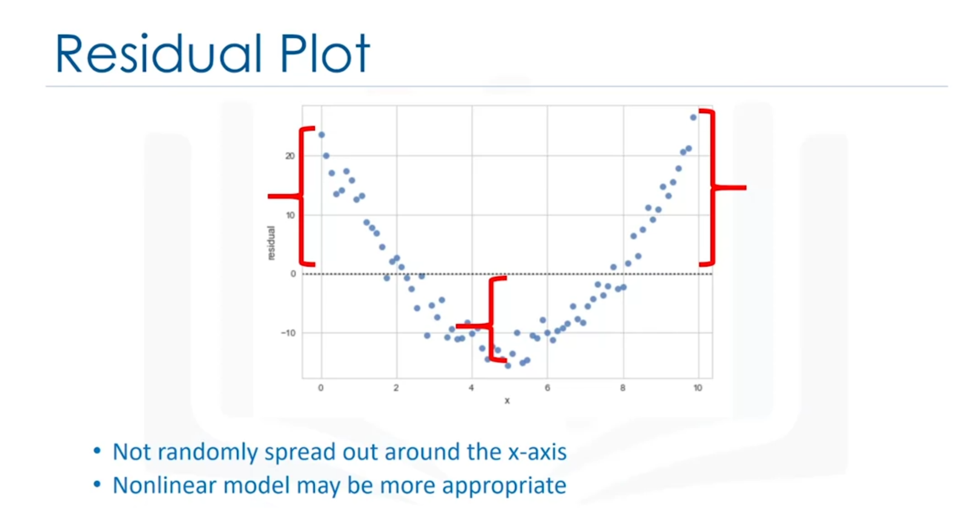

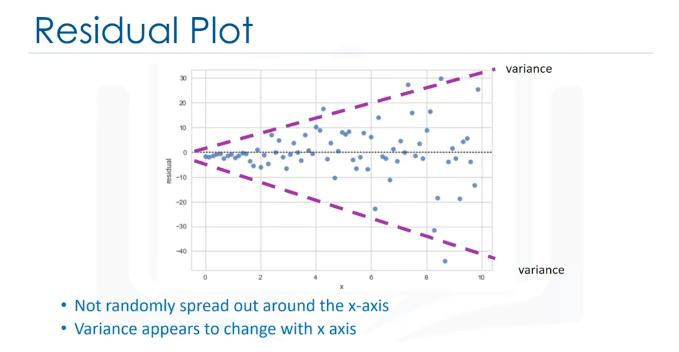

Model incorrect.

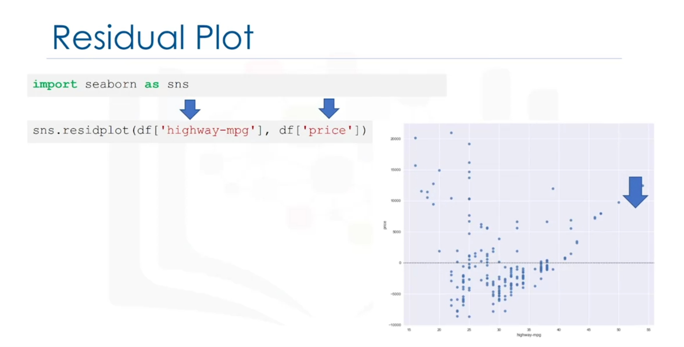

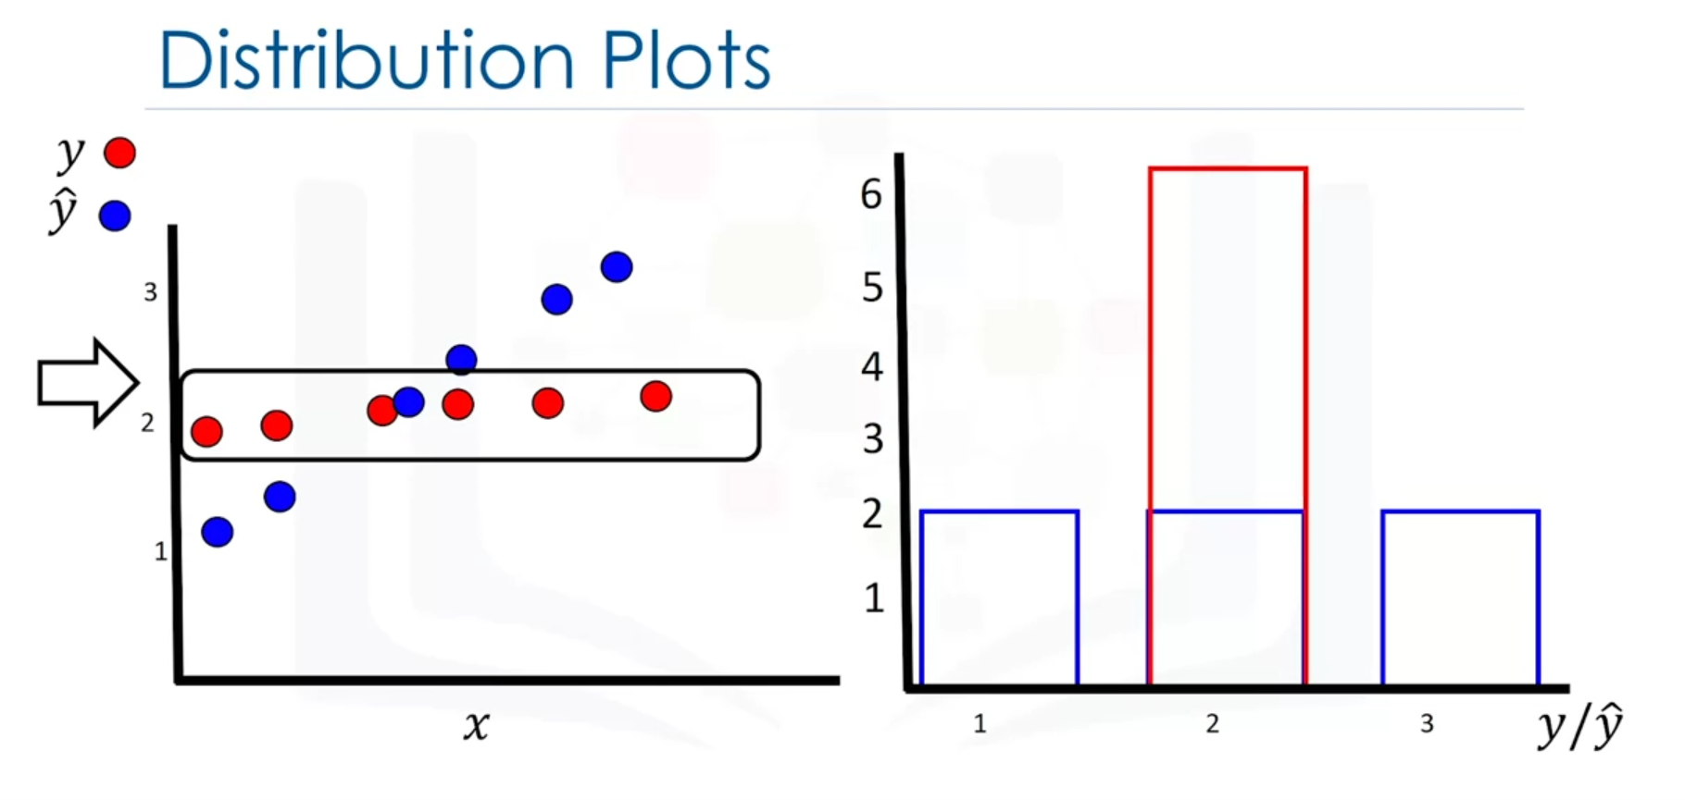

Y = actual values (?) and y hat = predictor values (?).

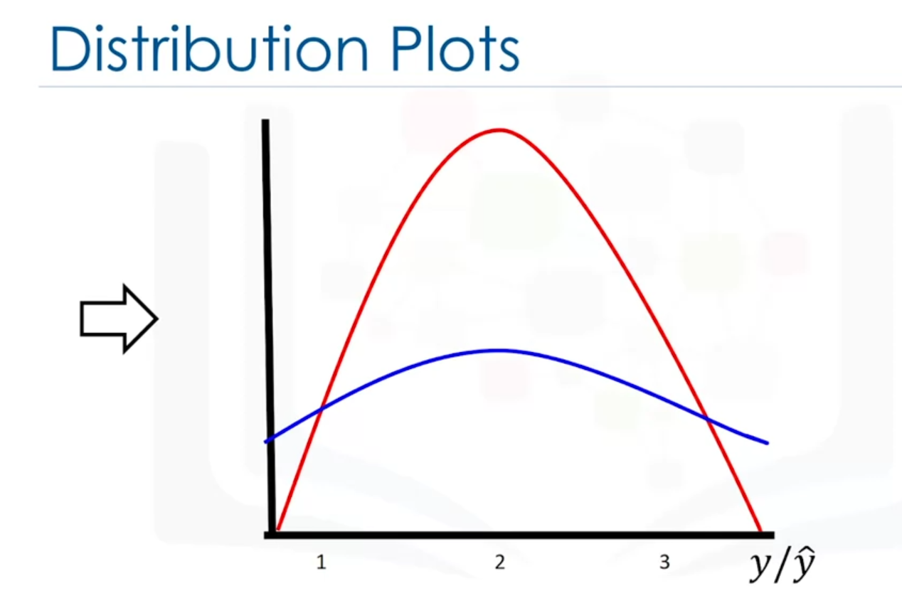

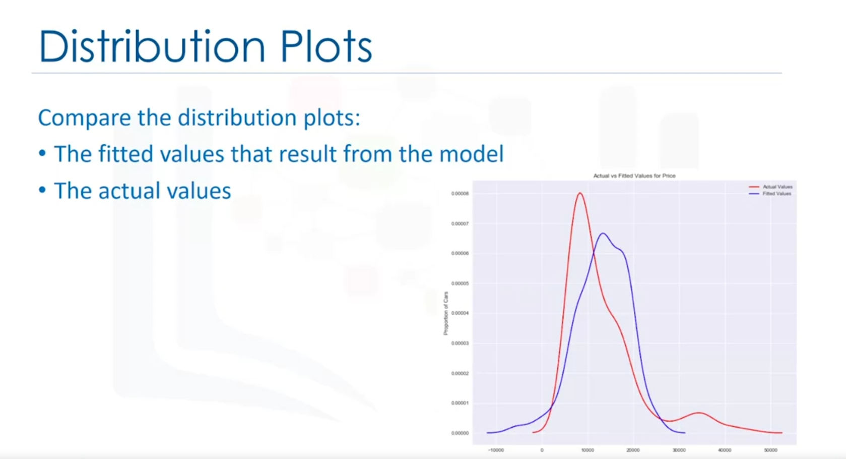

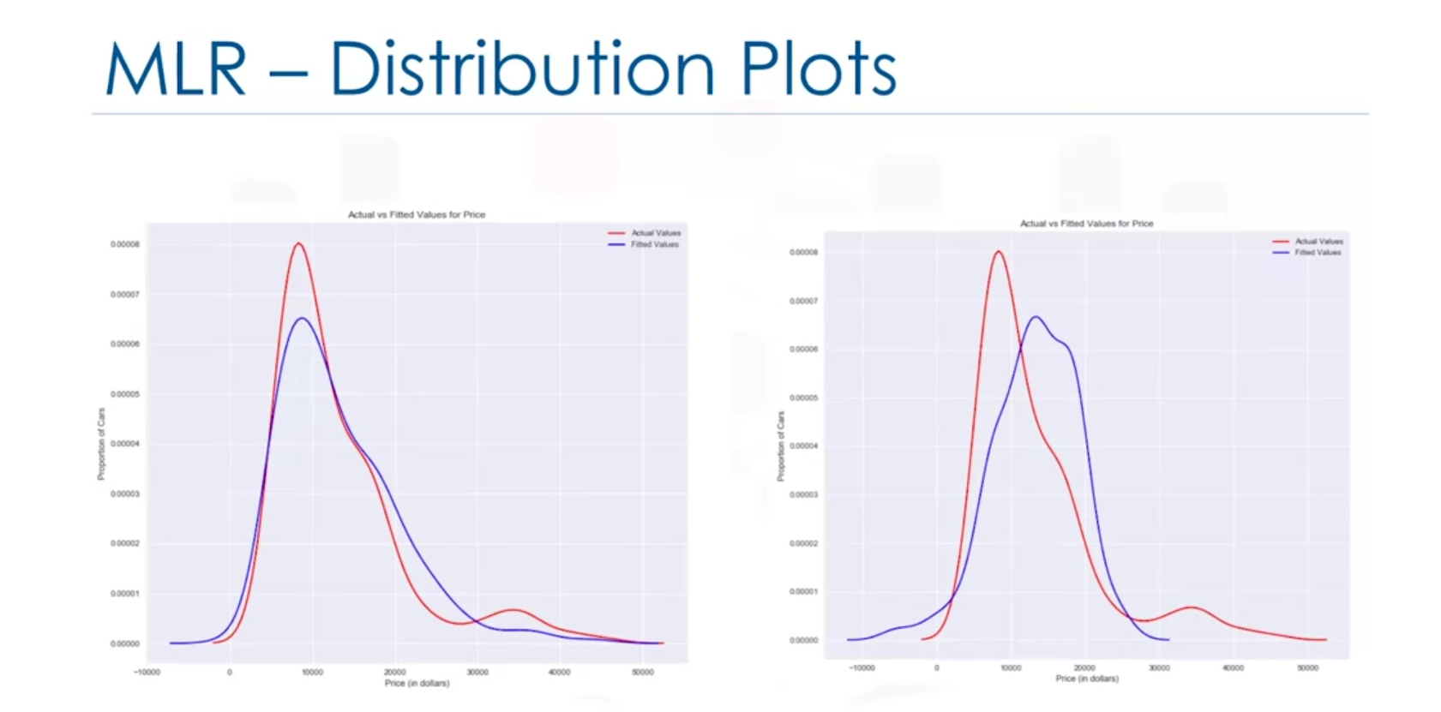

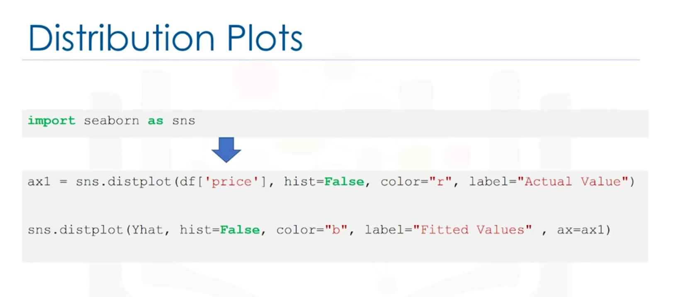

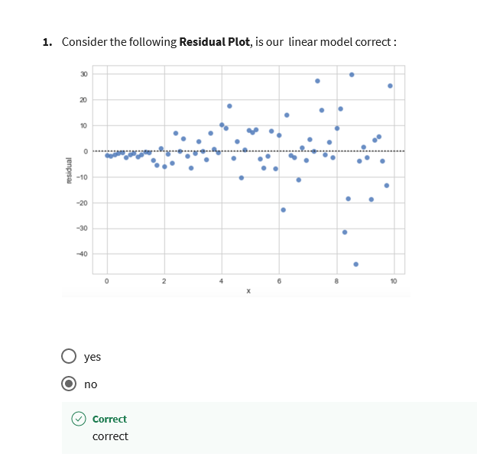

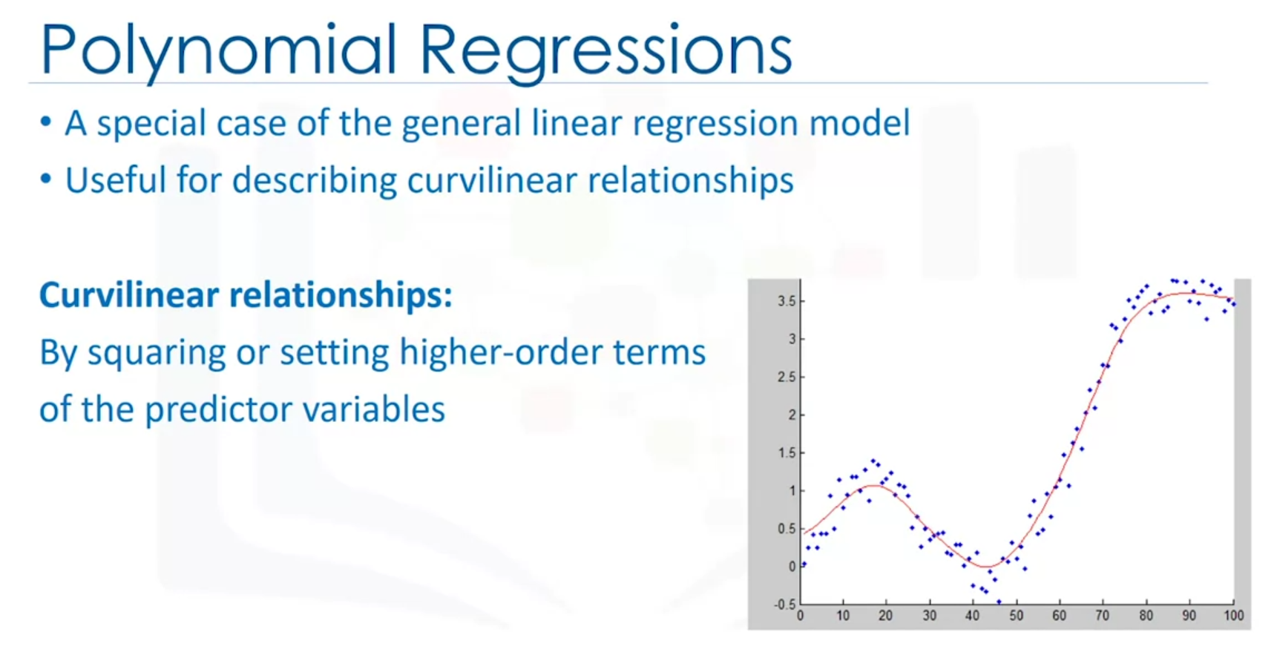

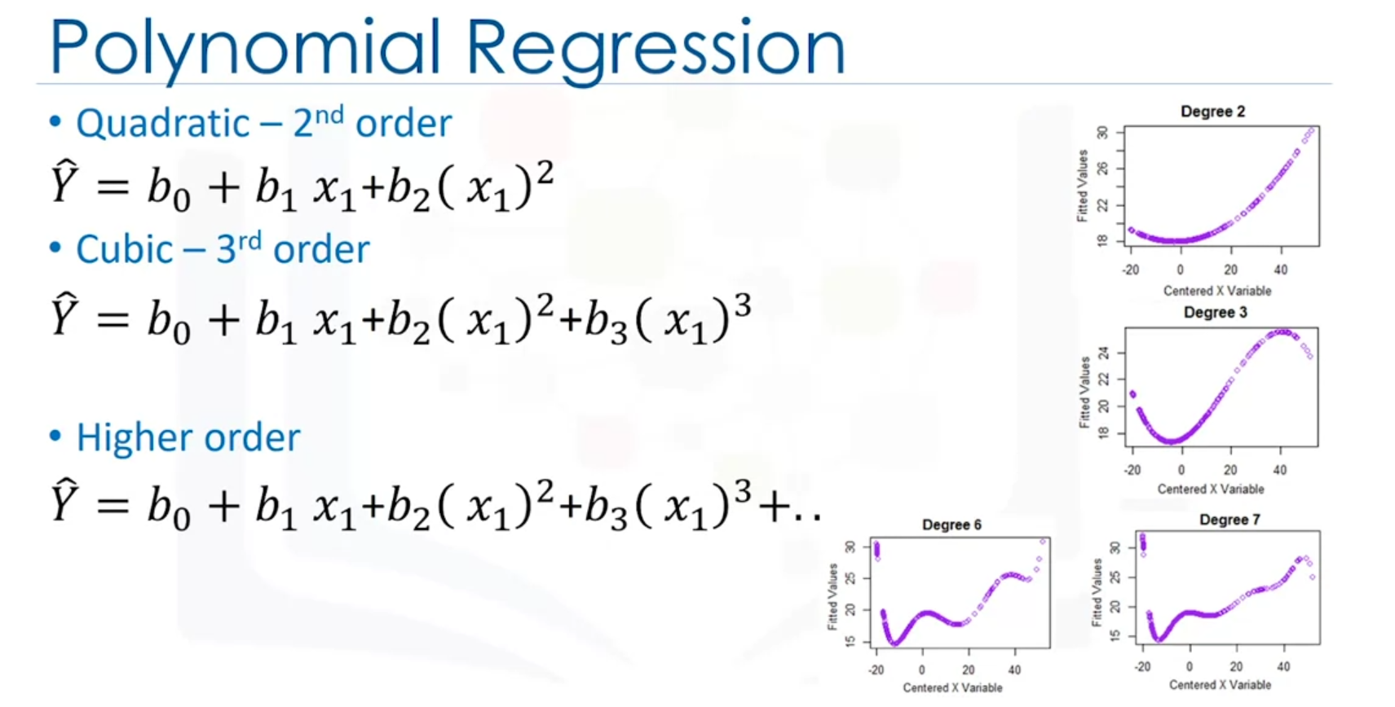

Higher order = better fit can be

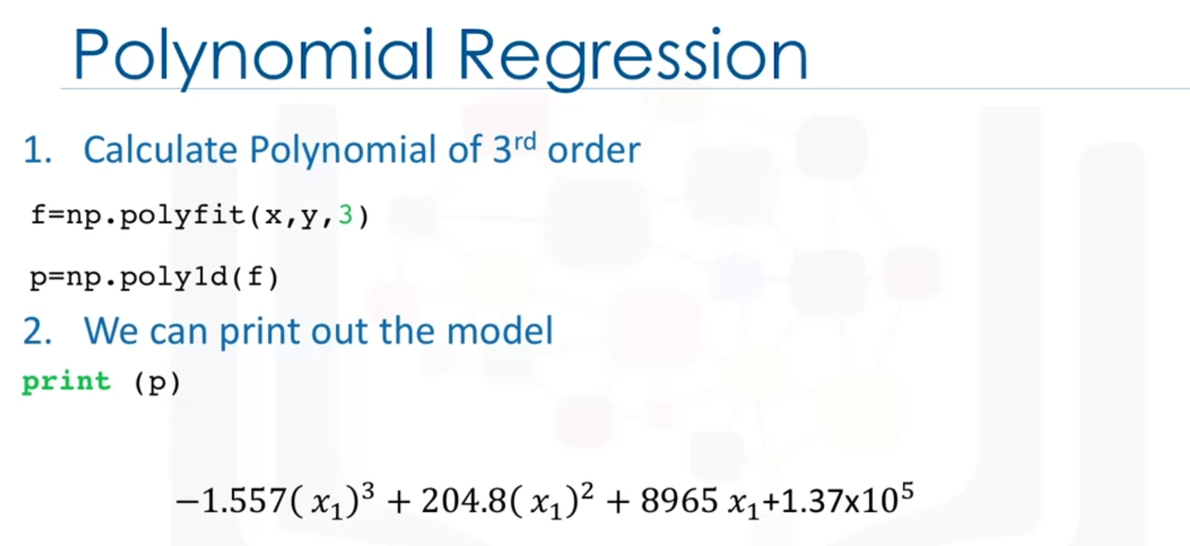

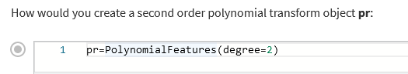

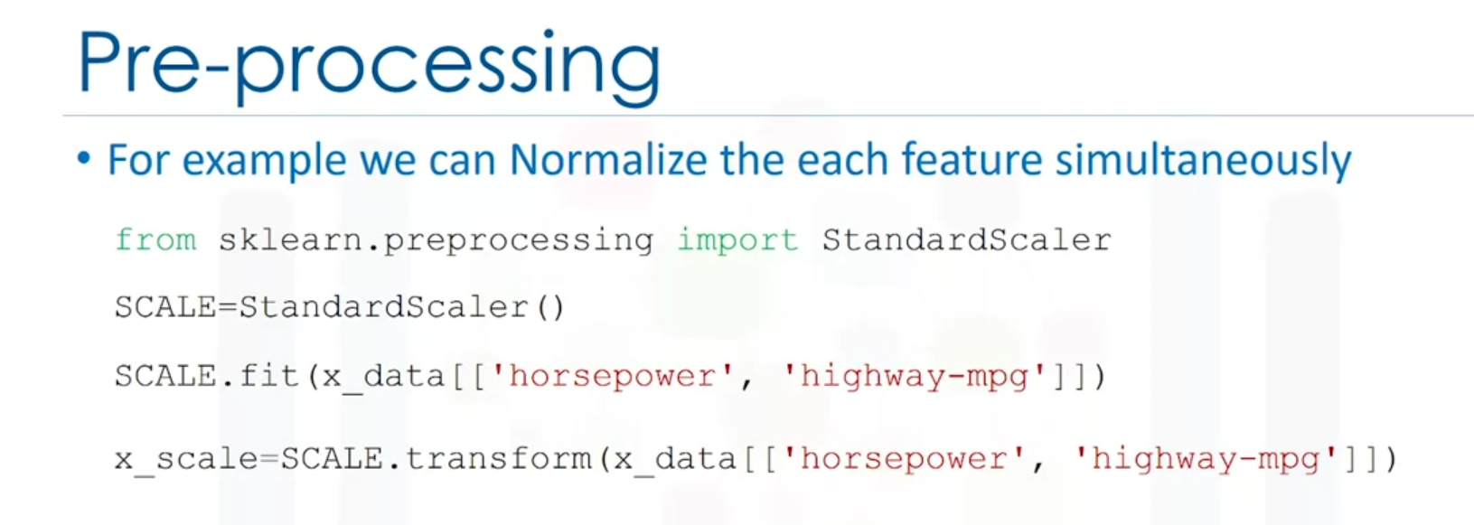

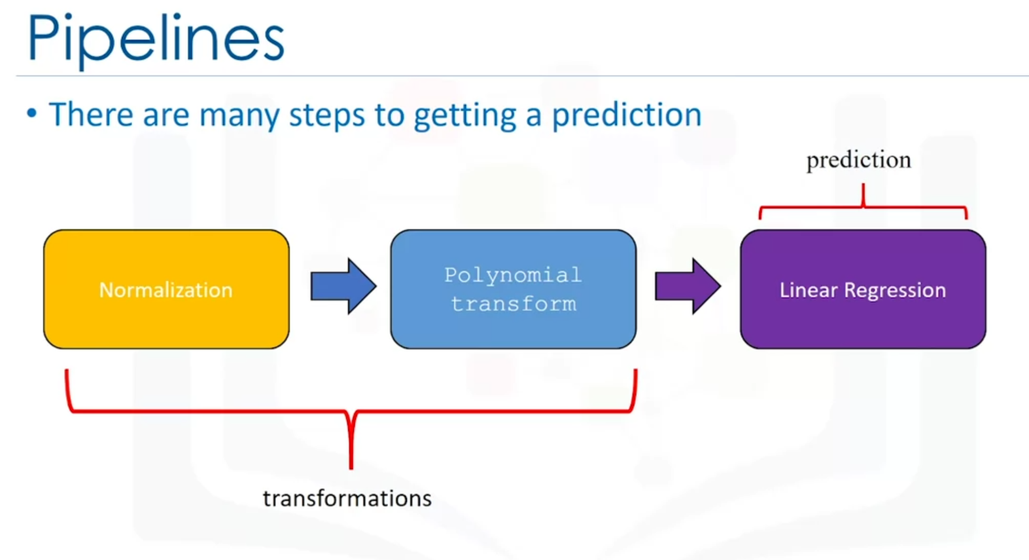

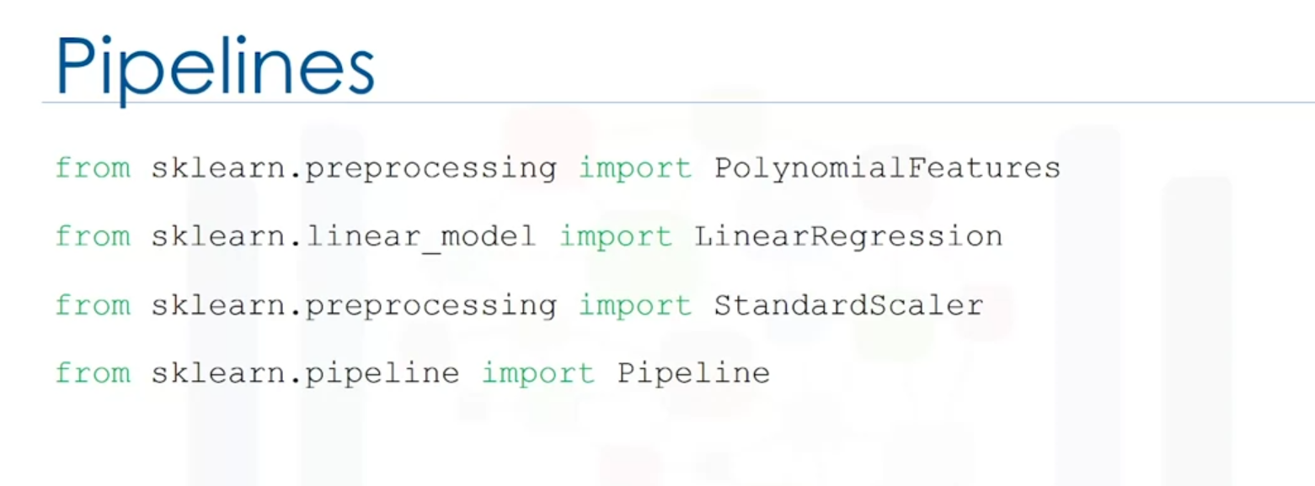

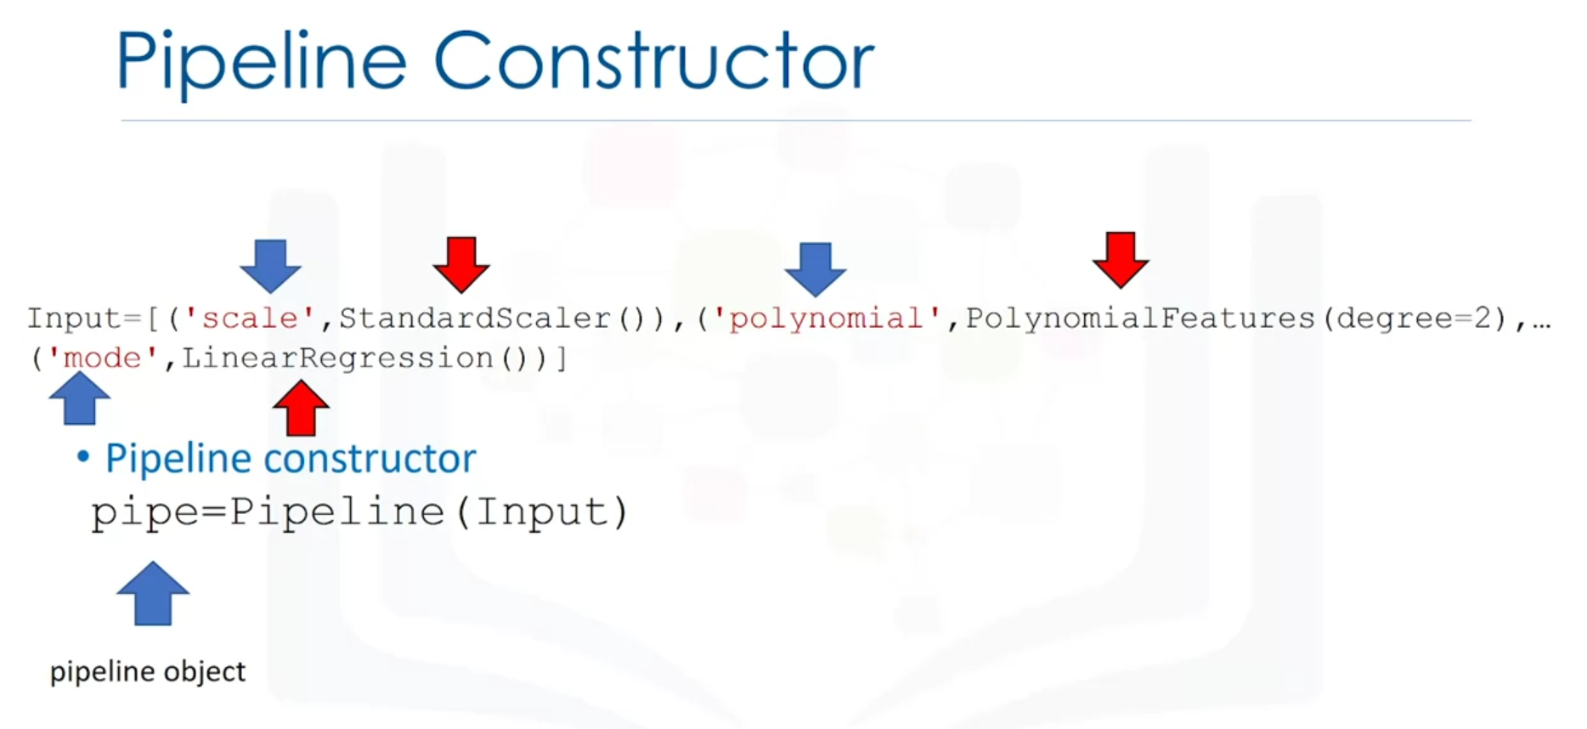

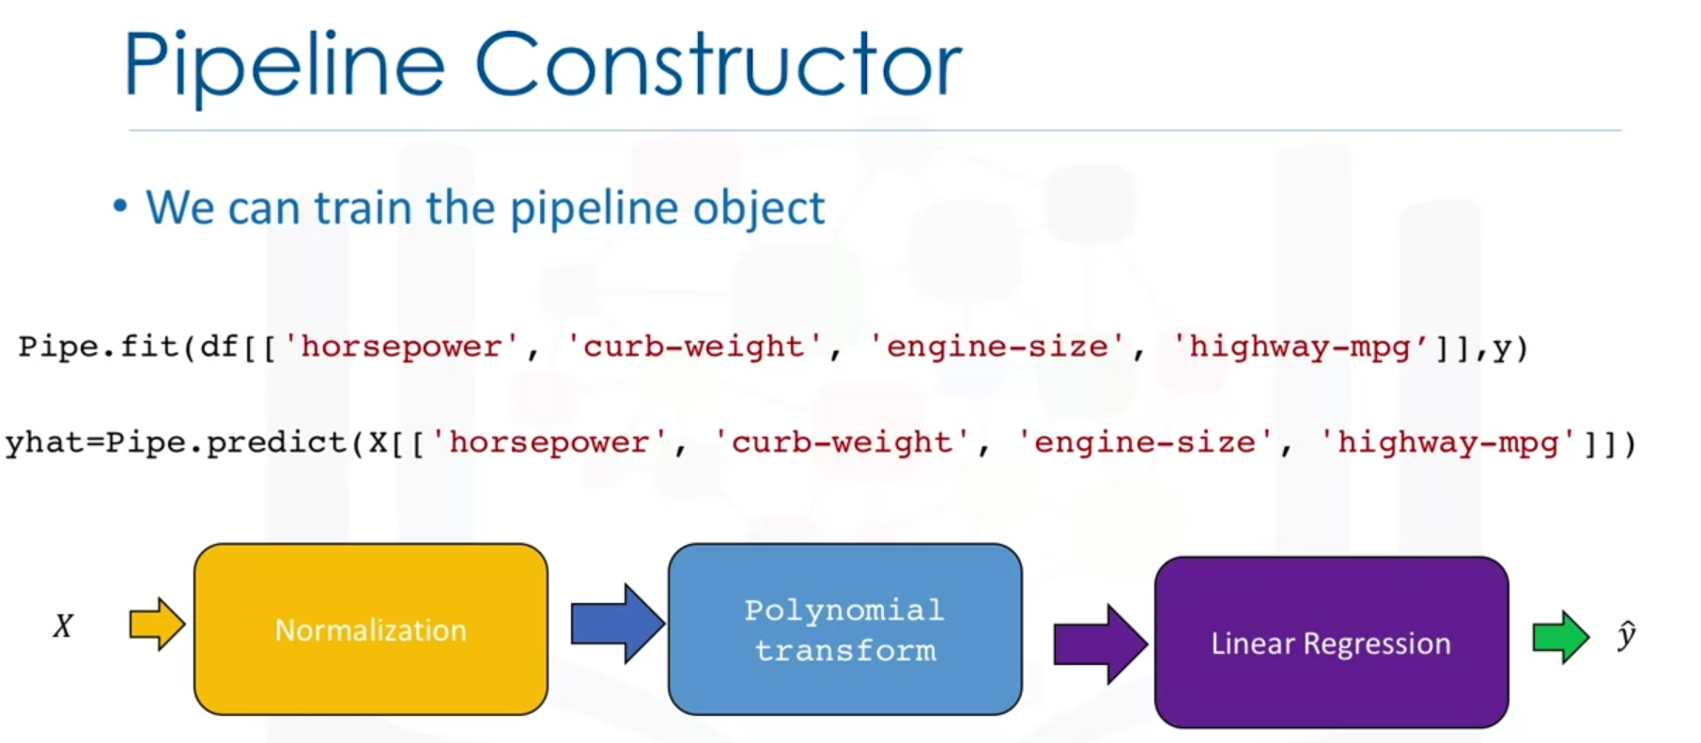

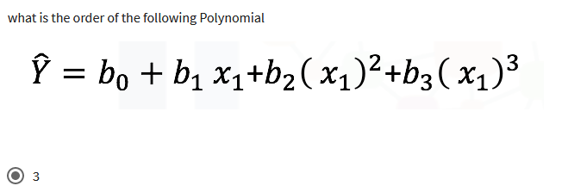

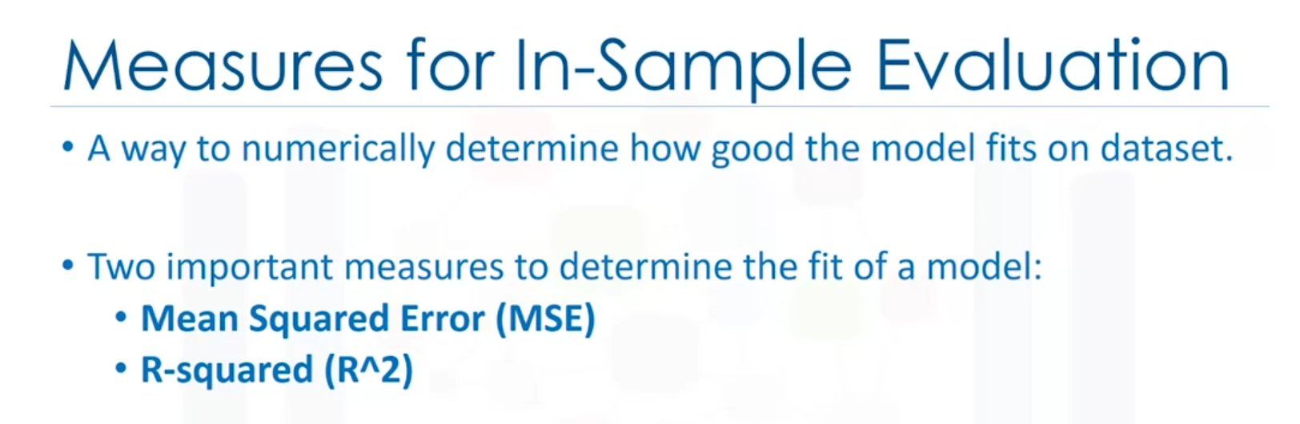

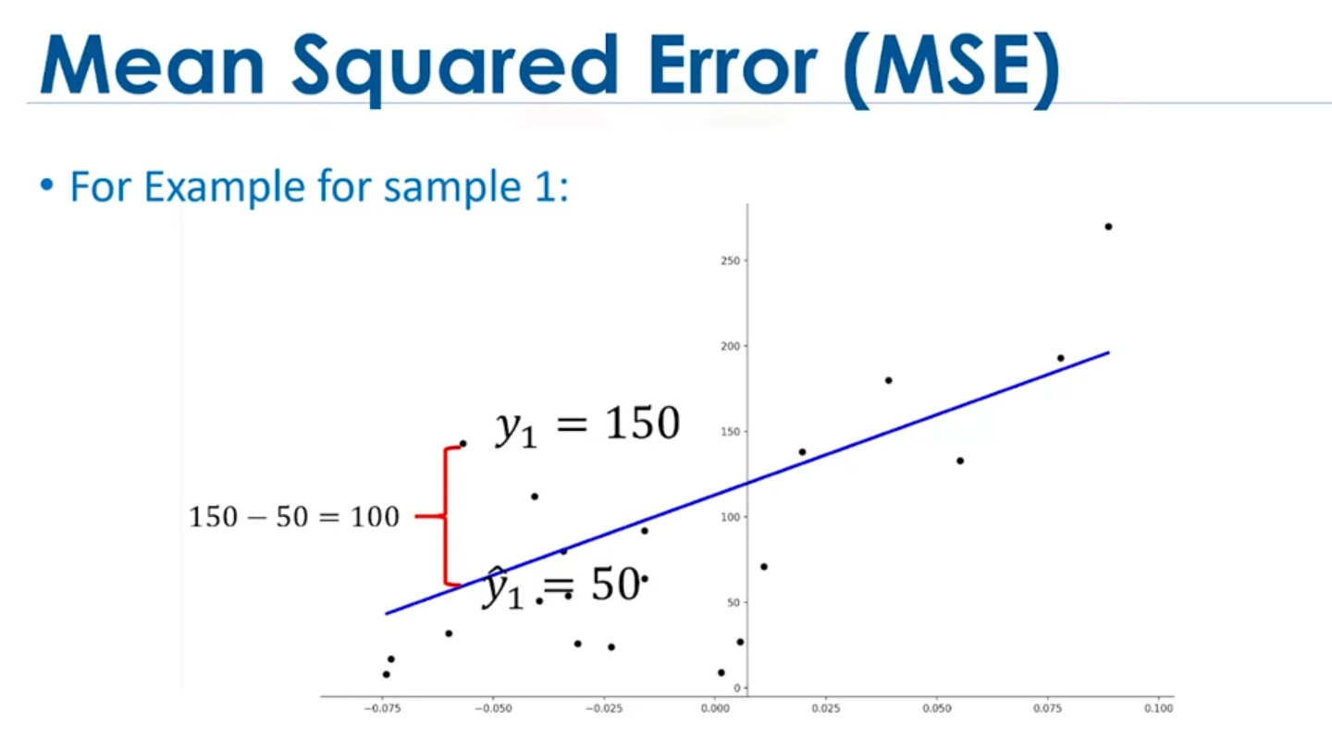

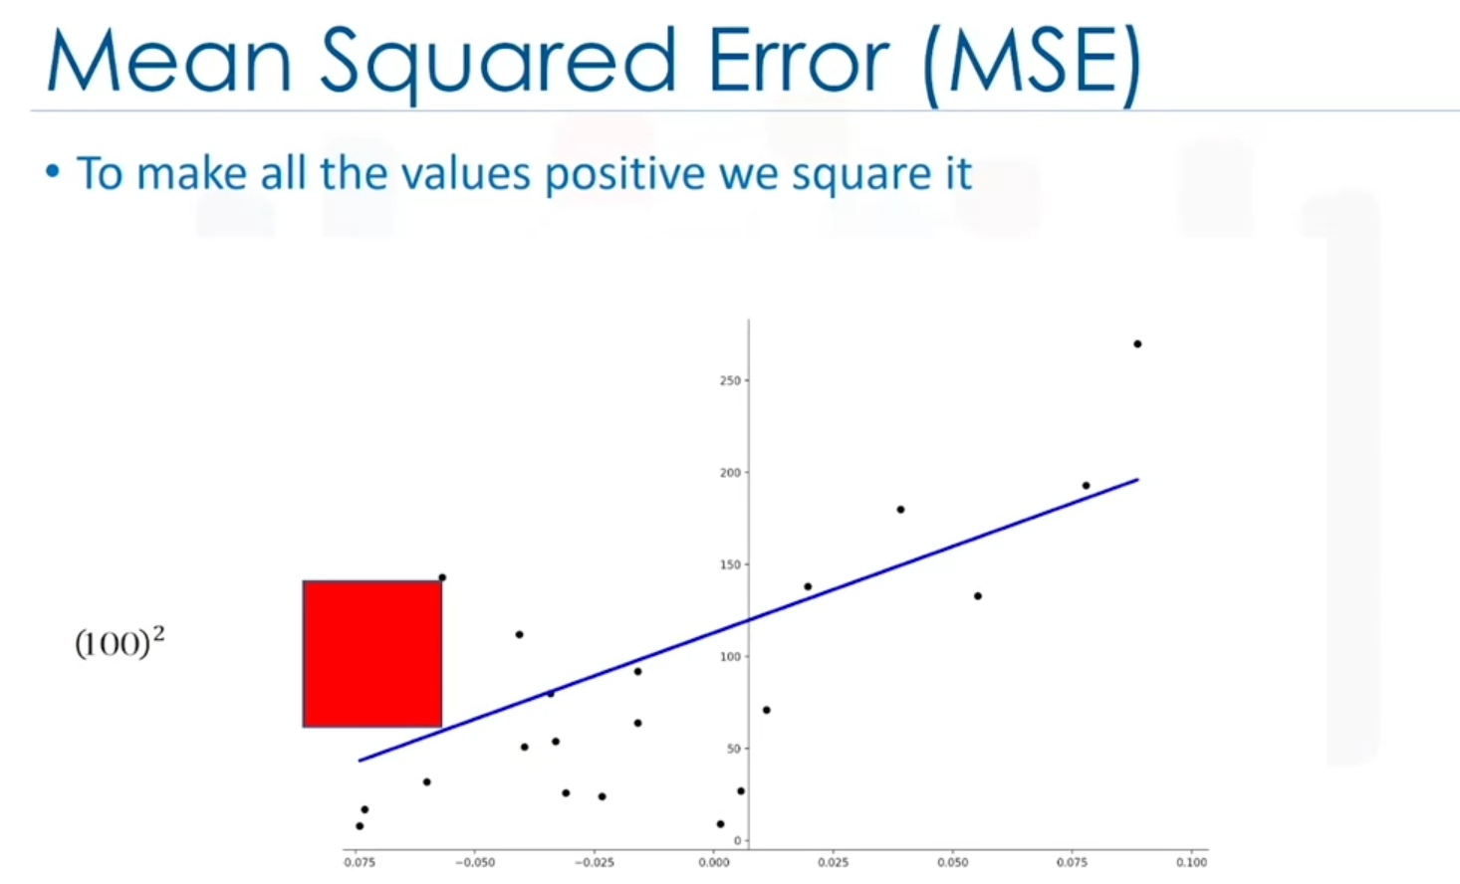

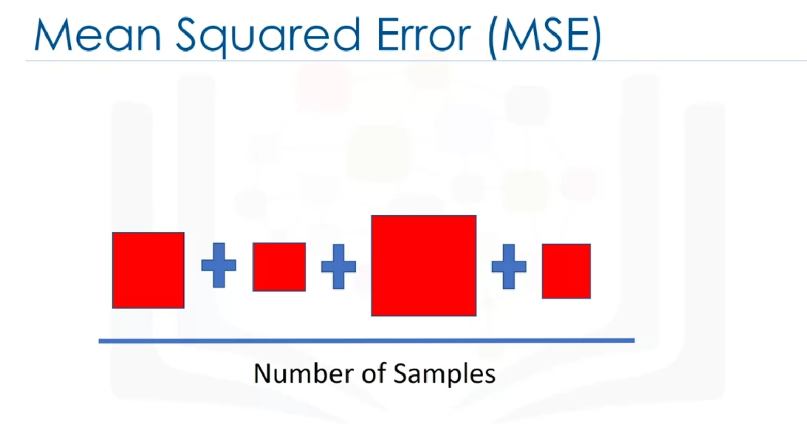

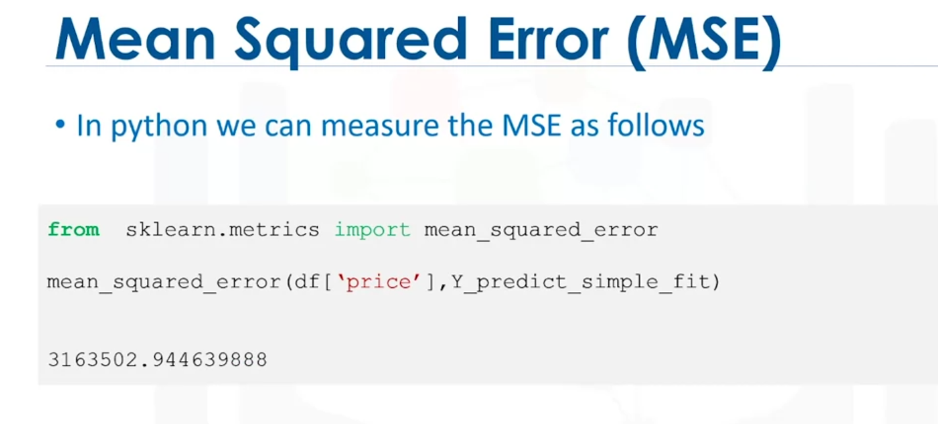

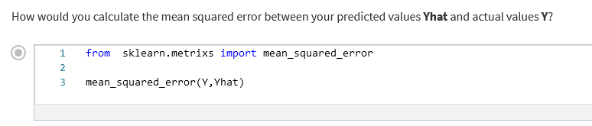

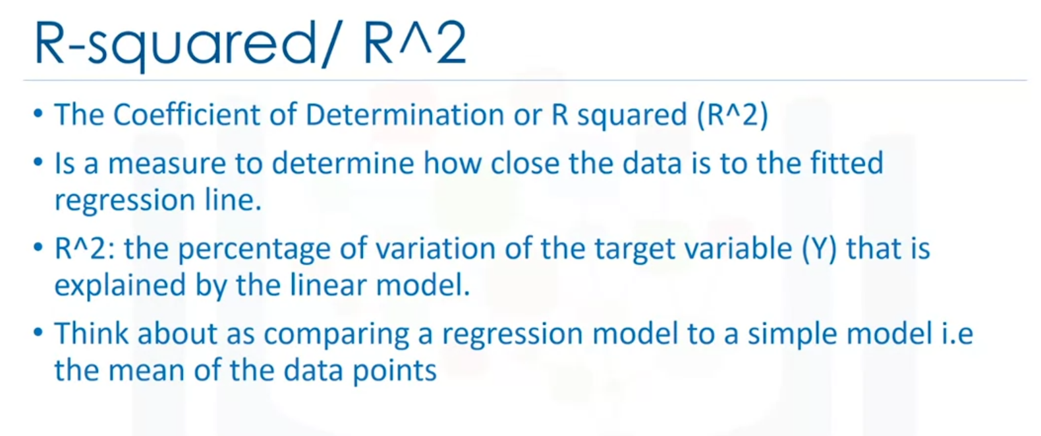

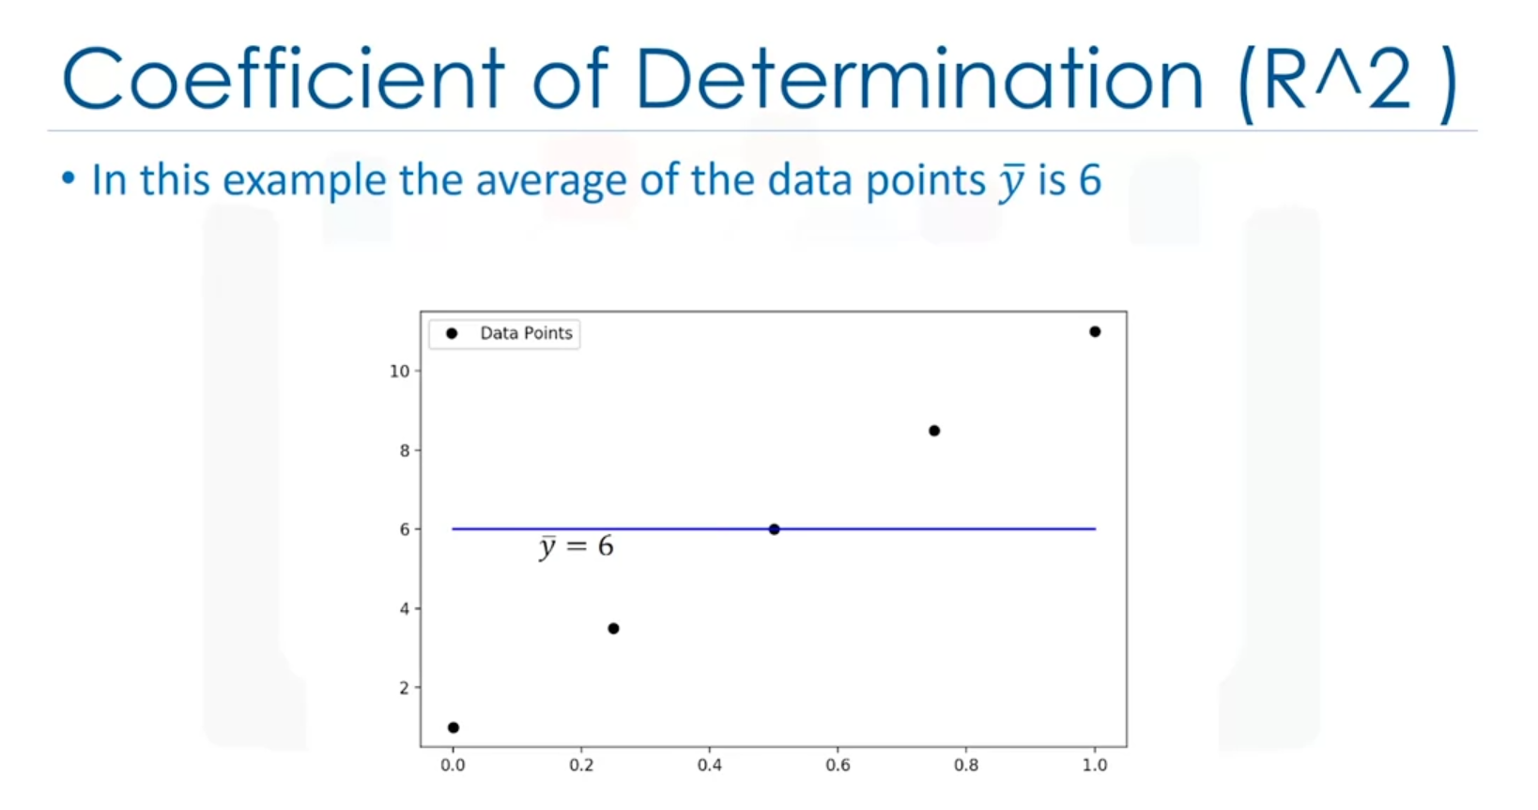

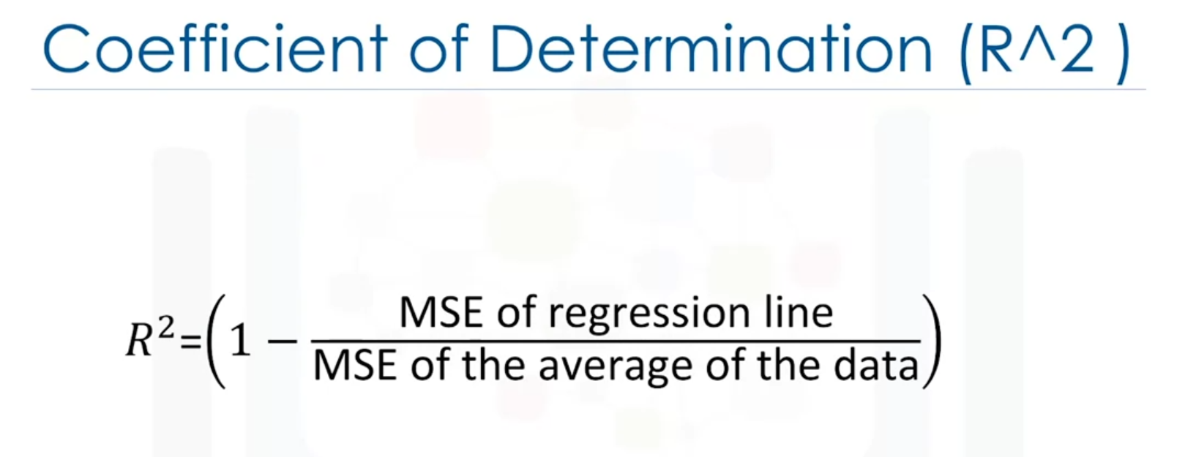

Y bar is the y above.

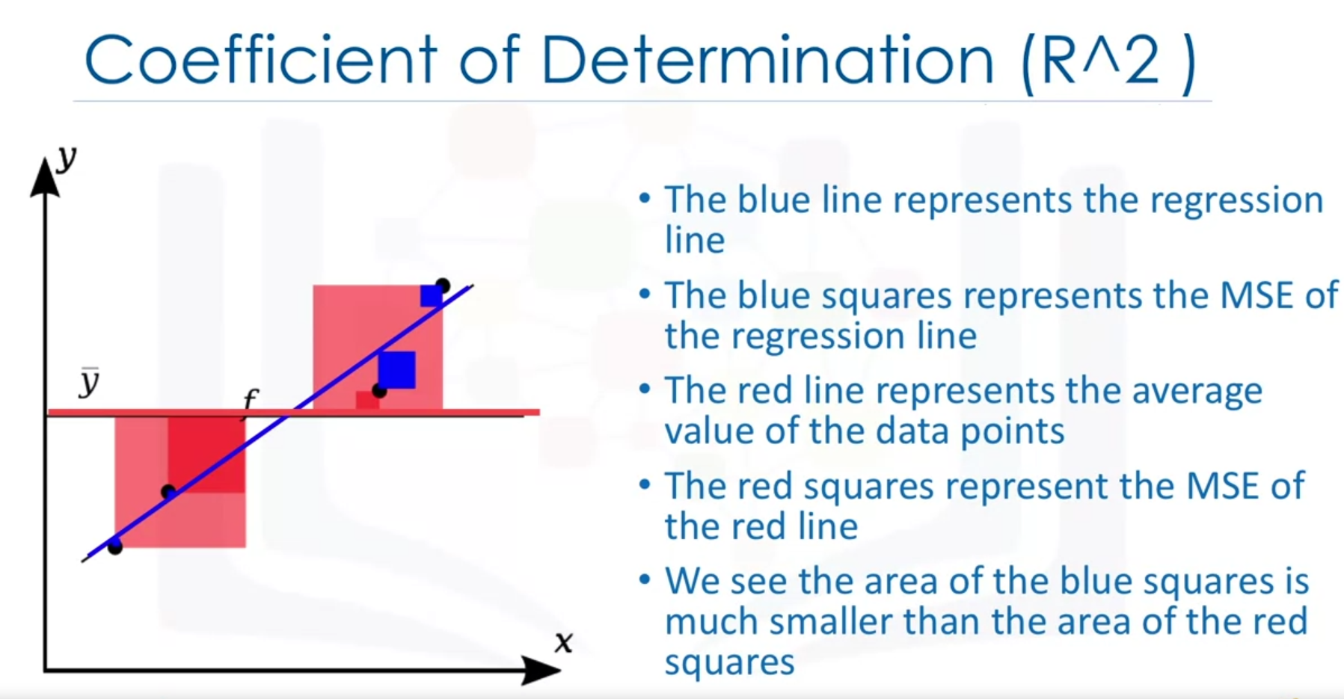

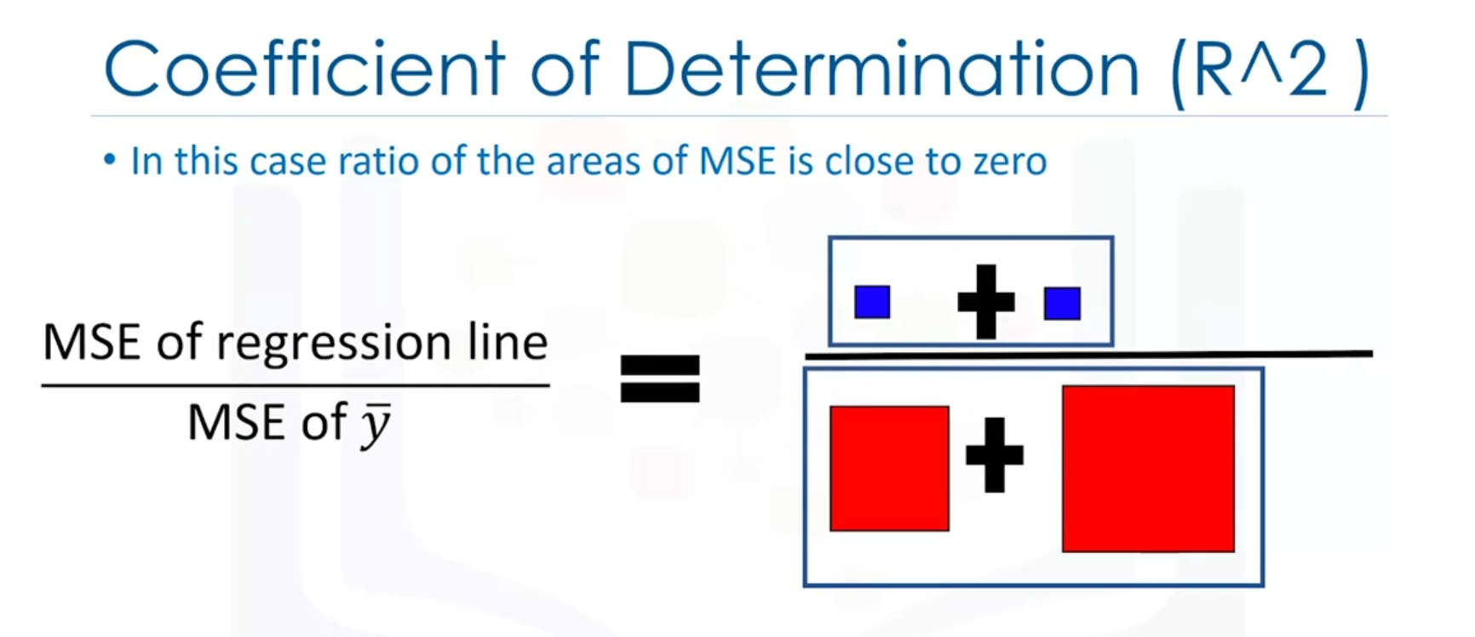

= 0

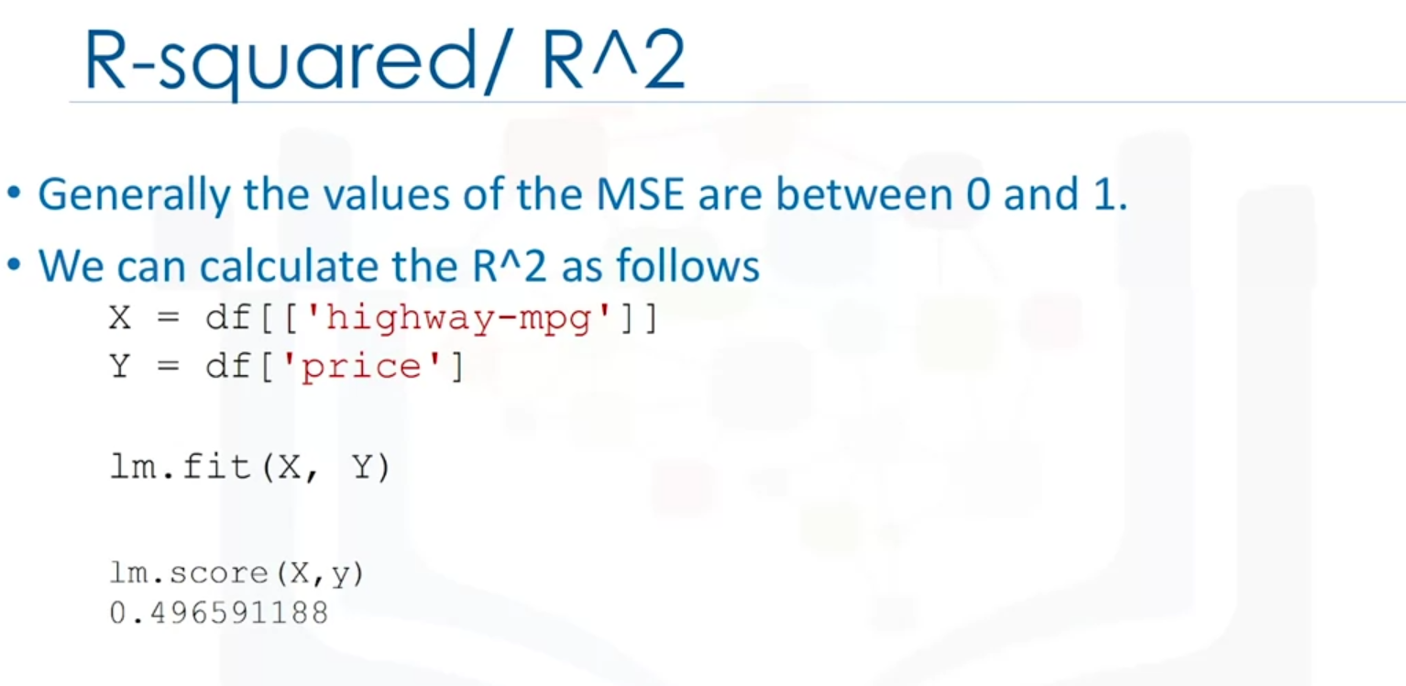

Minimum value of R2 is 0.

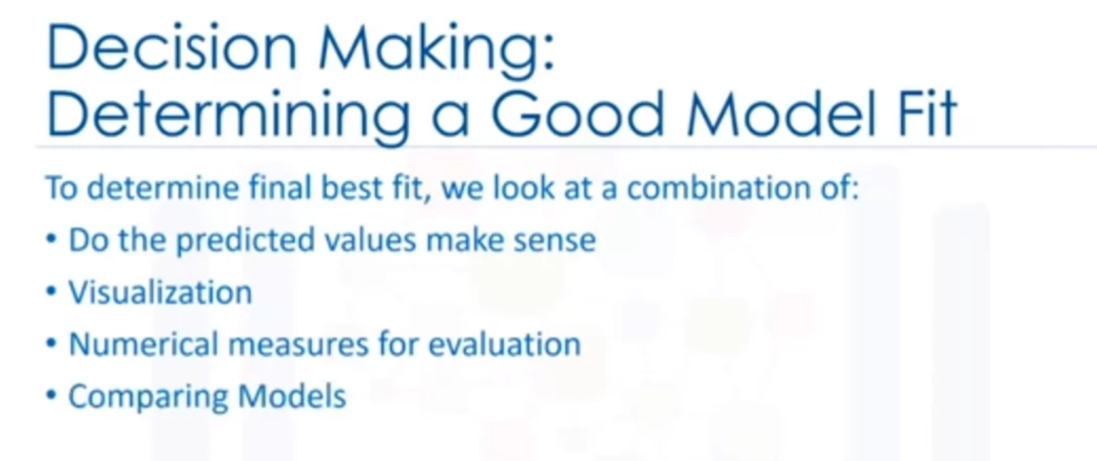

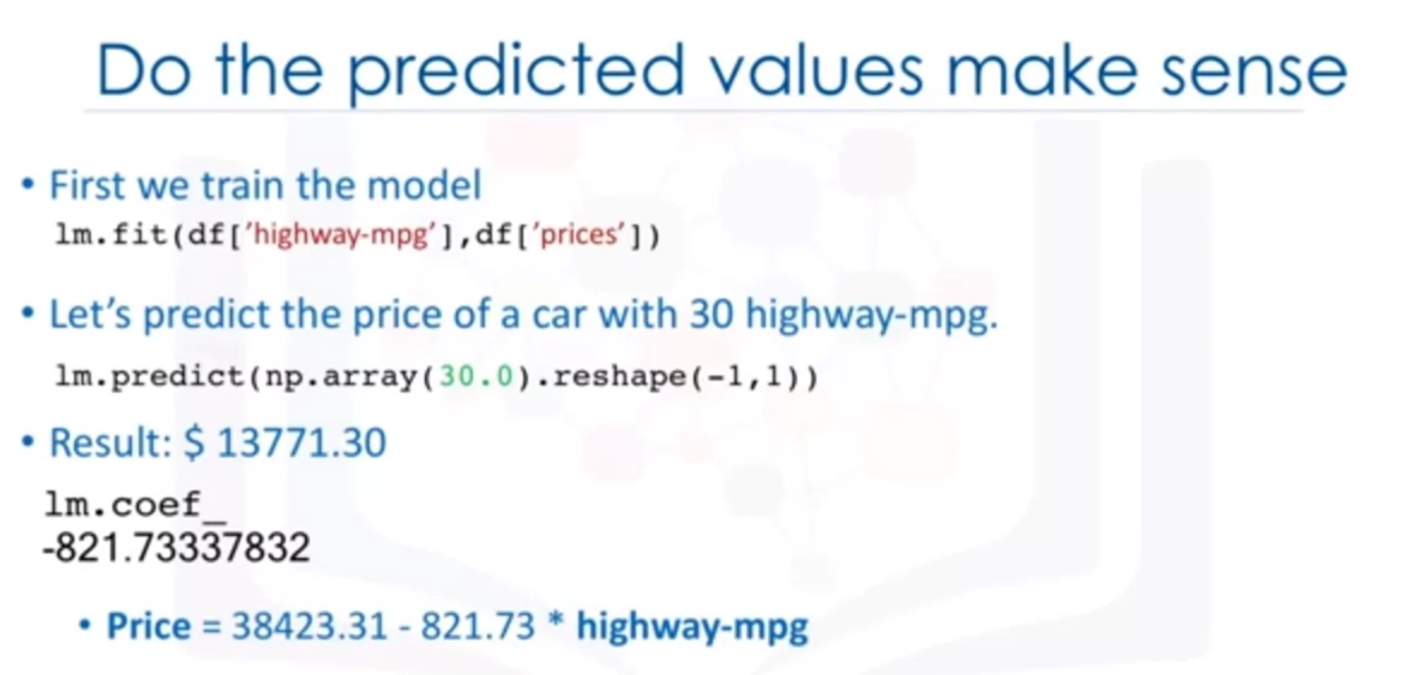

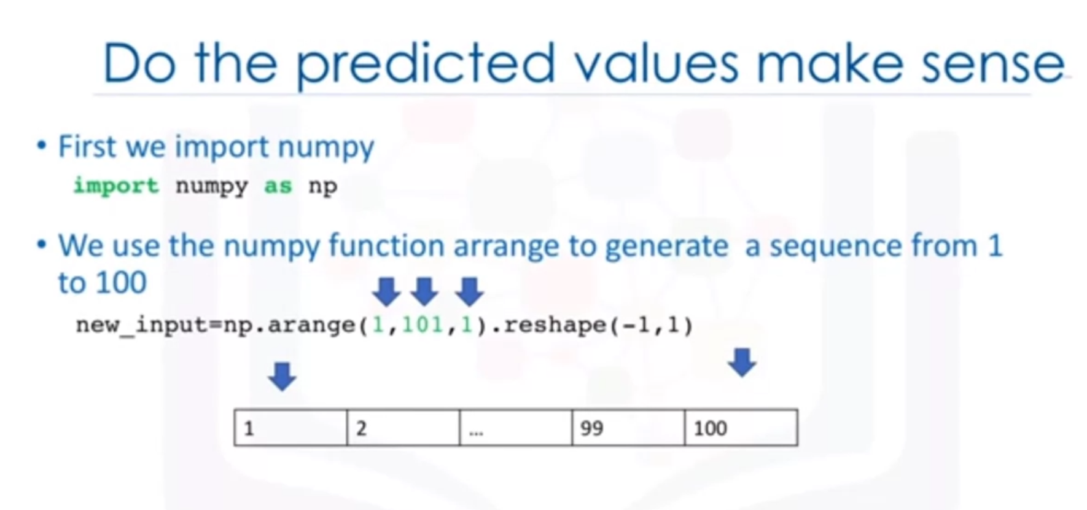



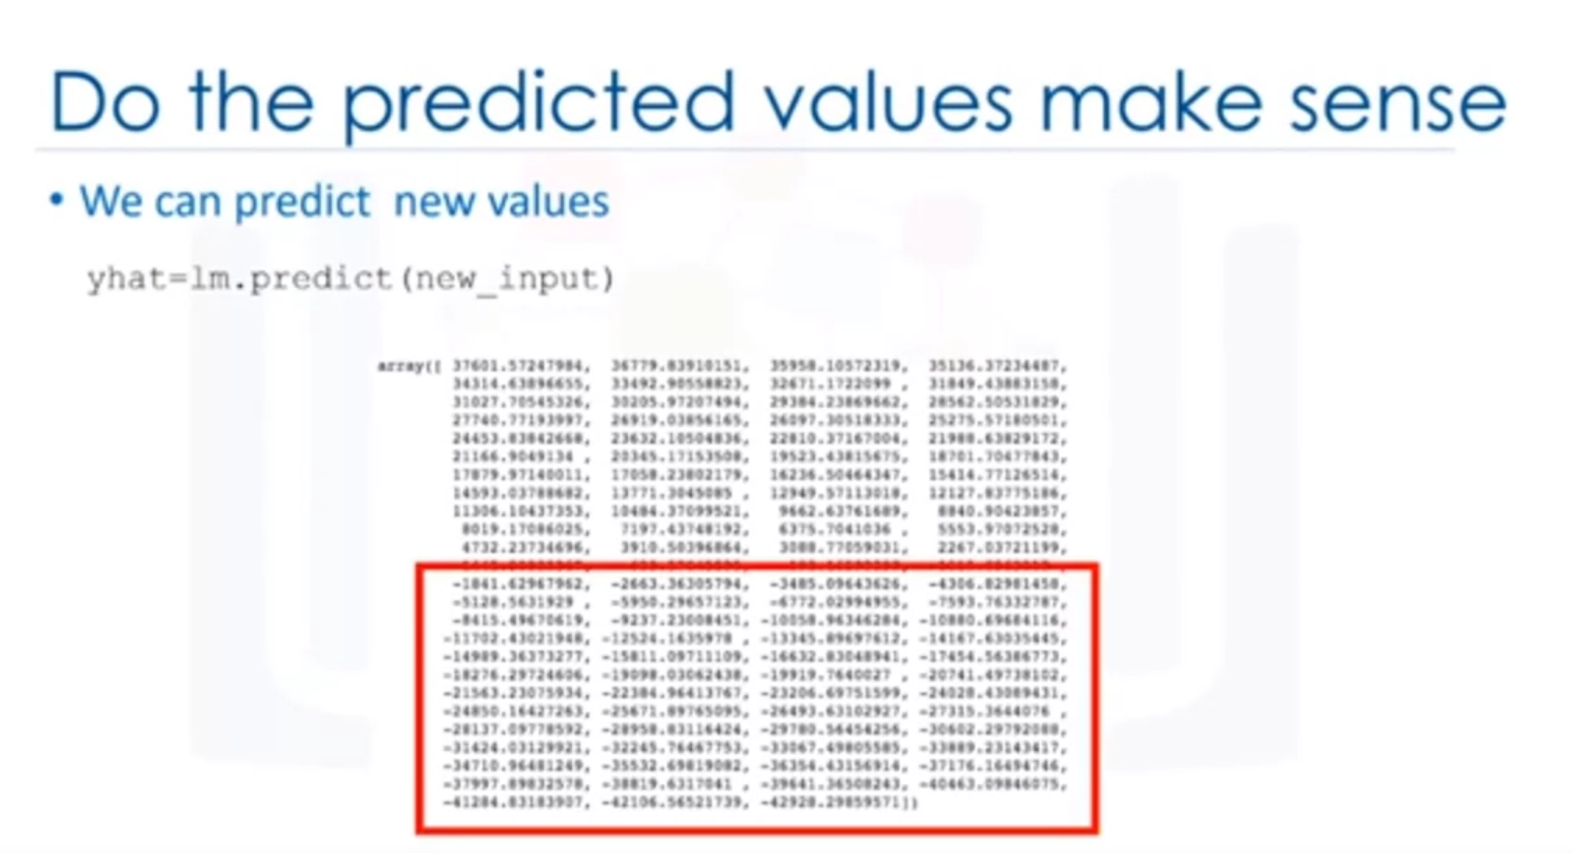

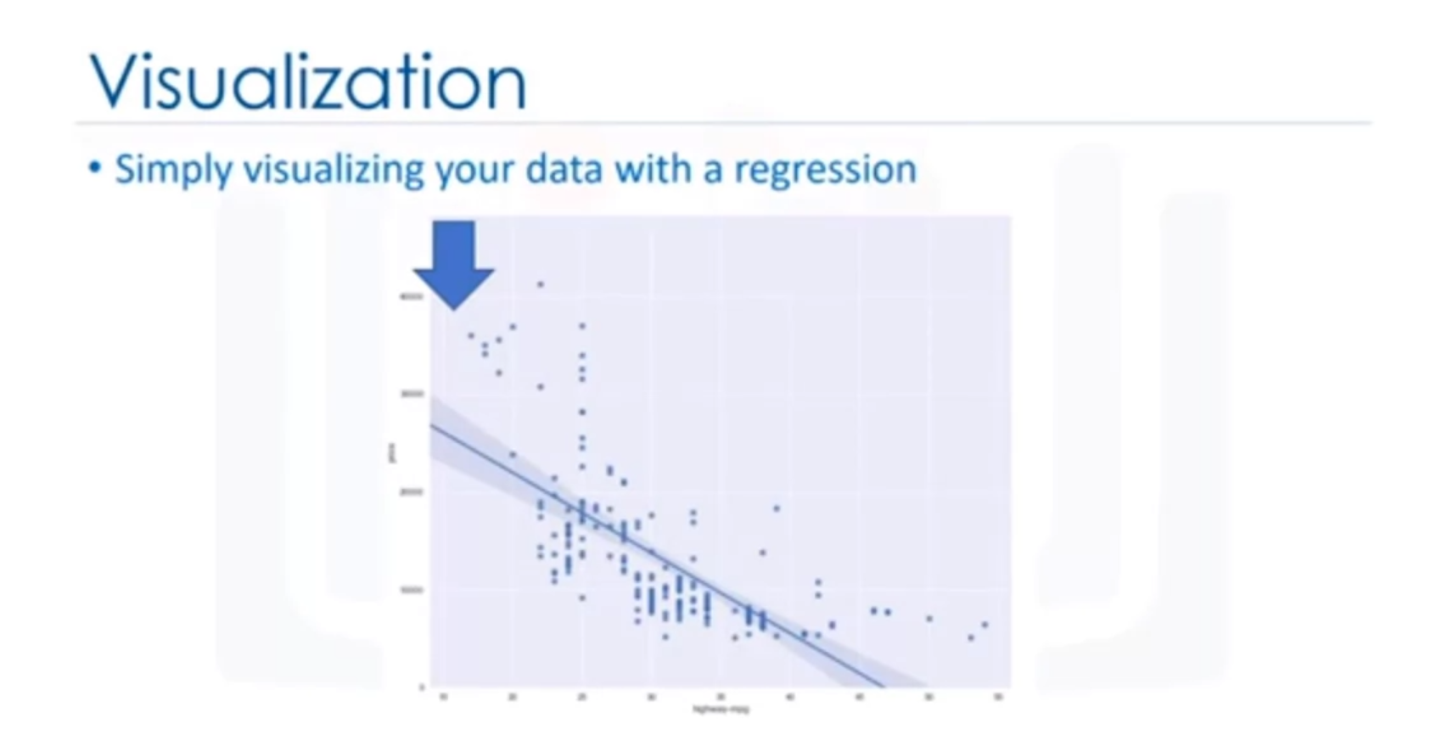

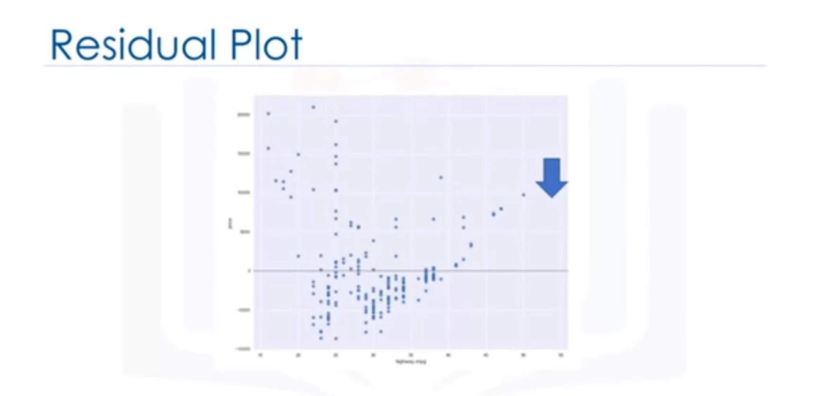

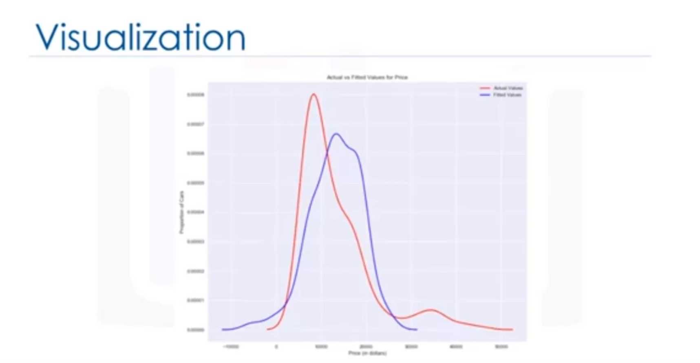

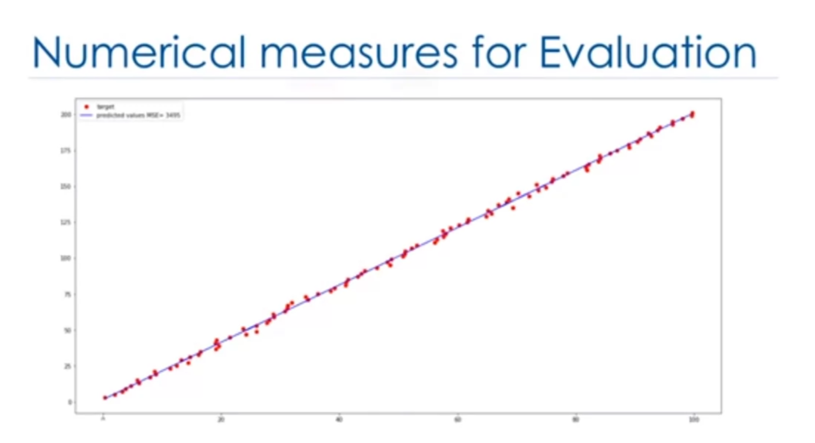

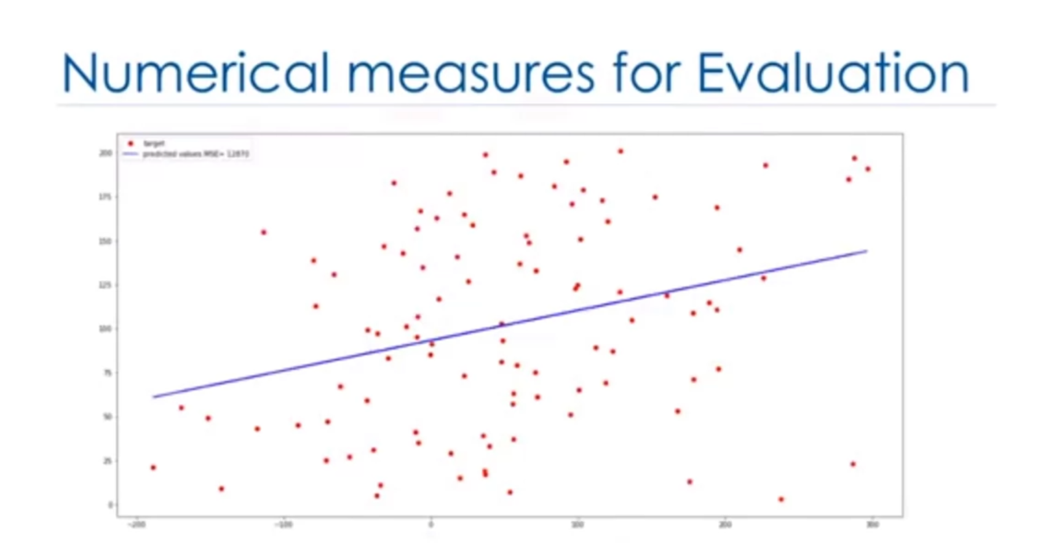

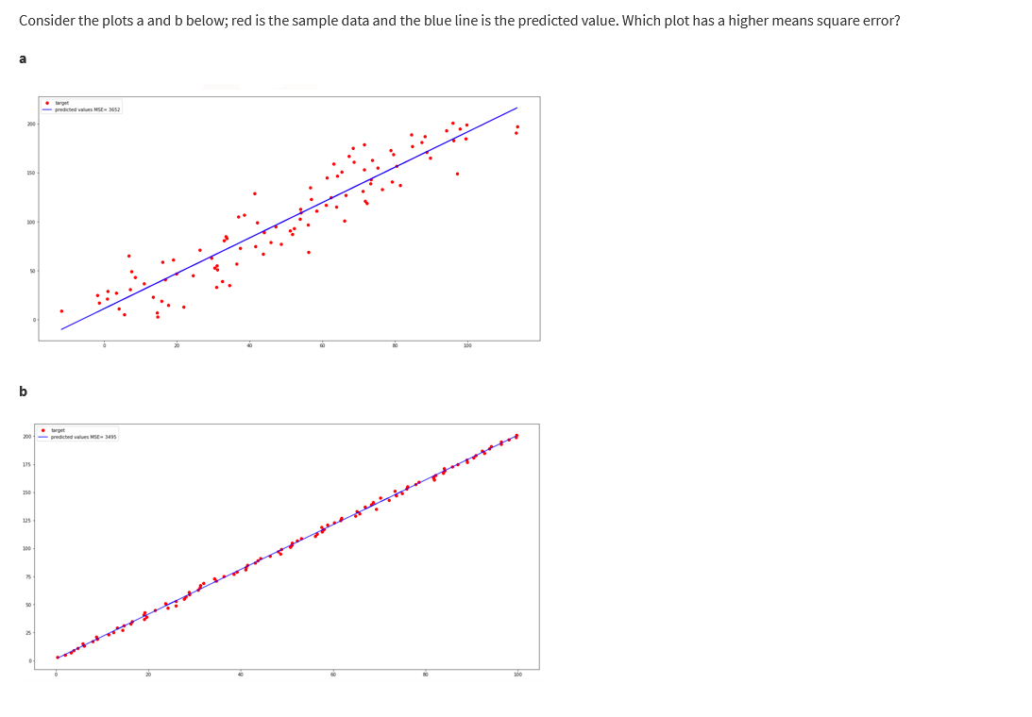

Plot a has a higher MSE.

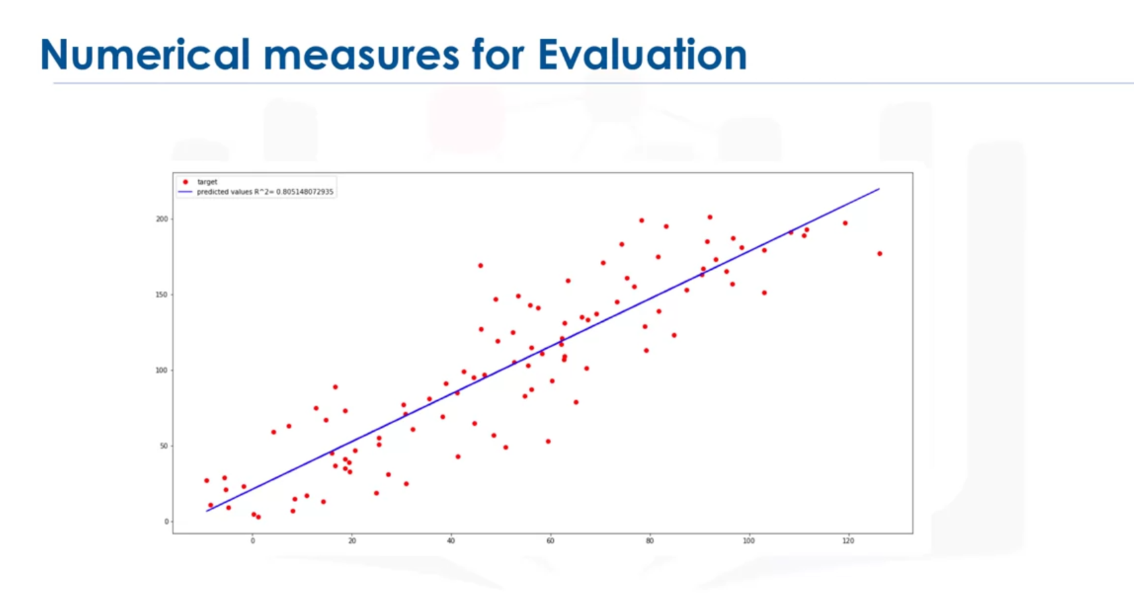

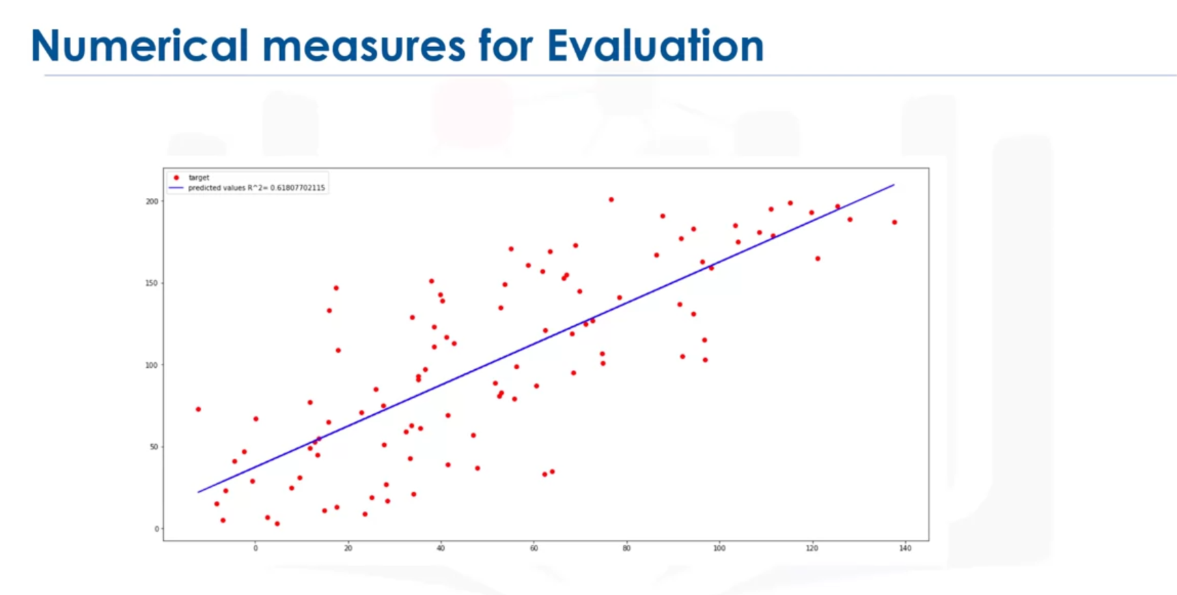60% of the observed variation is due to this value.

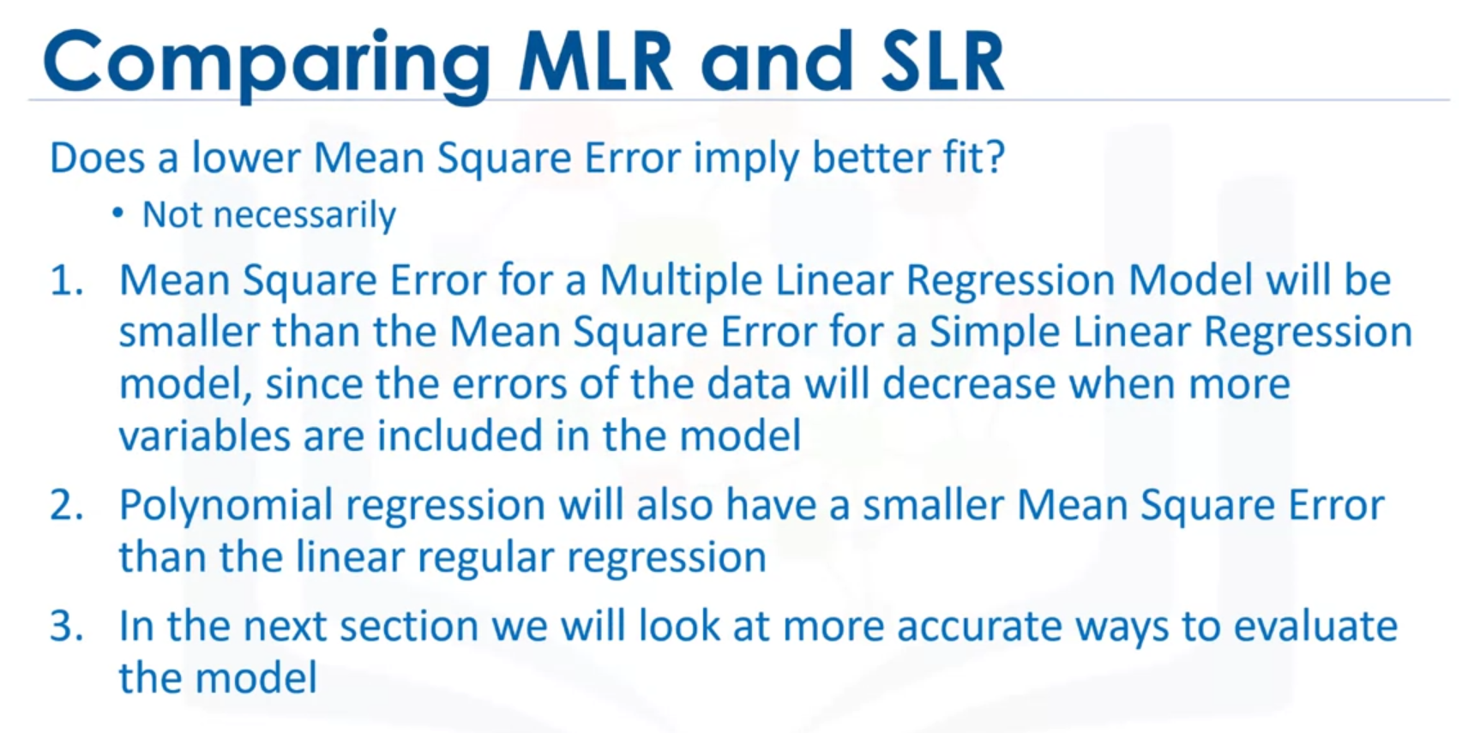

# Lesson Summary

In this lesson, you have learned how to:

**Define the explanatory variable and the response variable:** Define the response variable (y) as the focus of the experiment and the explanatory variable (x) as a variable used to explain the change of the response variable. Understand the differences between Simple Linear Regression because it concerns the study of only one explanatory variable and Multiple Linear Regression because it concerns the study of two or more explanatory variables.

**Evaluate the model using Visualization:** By visually representing the errors of a variable using scatterplots and interpreting the results of the model.

**Identify alternative regression approaches:** Use a Polynomial Regression when the Linear regression does not capture the curvilinear relationship between variables and how to pick the optimal order to use in a model.

**Interpret the R-square and the Mean Square Error:** Interpret R-square (x 100) as the percentage of the variation in the response variable y  that is explained by the variation in explanatory variable(s) x. The Mean Squared Error tells you how close a regression line is to a set of points. It does this by taking the average distances from the actual points to the predicted points and squaring them.

--

In data analytics, we often use **Model Development** to help us predict future observations from the data we have.

A model will help us understand the exact relationship between different variables and how these variables are used to predict the result.

## 1. Linear Regression and Multiple Linear Regression

#### Linear Regression

One example of a Data Model that we will be using is:

**Simple Linear Regression**

Simple Linear Regression is a method to help us understand the relationship between two variables:

* The predictor/independent variable (X)
* The response/dependent variable (that we want to predict)(Y)

The result of Linear Regression is a **linear function** that predicts the response (dependent) variable as a function of the predictor (independent) variable.

*𝑌*:*𝑅𝑒𝑠𝑝𝑜𝑛𝑠𝑒* *𝑉𝑎𝑟𝑖𝑎𝑏𝑙𝑒𝑋*:*𝑃𝑟𝑒𝑑𝑖𝑐𝑡𝑜𝑟* *𝑉𝑎𝑟𝑖𝑎𝑏𝑙𝑒𝑠*

**Linear Function**

*𝑌ℎ𝑎𝑡*=*𝑎*+*𝑏𝑋*

* a refers to the **intercept** of the regression line, in other words: the value of Y when X is 0
* b refers to the **slope** of the regression line, in other words: the value with which Y changes when X increases by 1 unit